Anaesthetics SAQ 1

Rebecca Day

Pre-Accident (patients Employment ID Card)
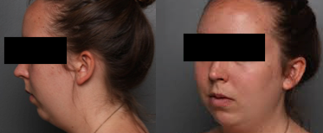

Post Intubation in ED
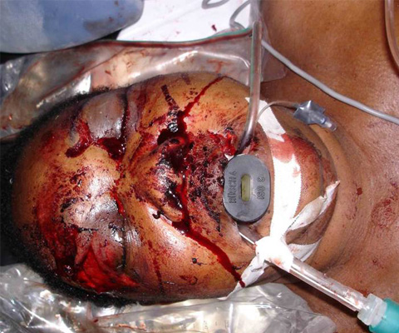

A 24 year old woman is BIBA after being involved in a head on MVA at high speed. She was the unrestrained driver travelling at high speed. She was agitated and confused (GCS 10), with Cspine precautions in situ on arrival.

Observations PRE-INTUBATION

P 130
BP 90/60
Sats 91% (FI02 1.0)
RR 28
Temp 35.6

Question 1
The decision is made to intubate. What are the factors that will make safe intubation with an RSI more difficult in this case ? (Max 6 – BOLD necessary)

Question 2
State the measures that you will employ to improve your chances of successful first pass intubation without complications? (Max 7)

Question 3
First pass intubation appears successful, how will you confirm the correct position of the ETT? (Max 3 – Bold necessary)

