Syncope SAQ

A 16 year old boy with a congenital heart problem presents to ED with episodes of syncope. This is his ECG.

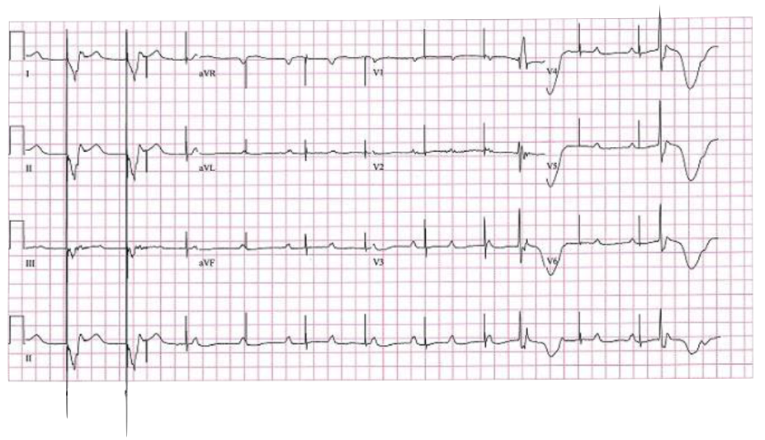

Describe the ECG (5 marks)

Name 5 potential causes for this appearance (5 marks)

Source: Fellowship VAQ 2013.1

