Syncope SAQ

A 16 year old boy with a congenital heart problem presents to ED with episodes of syncope. This is his ECG.

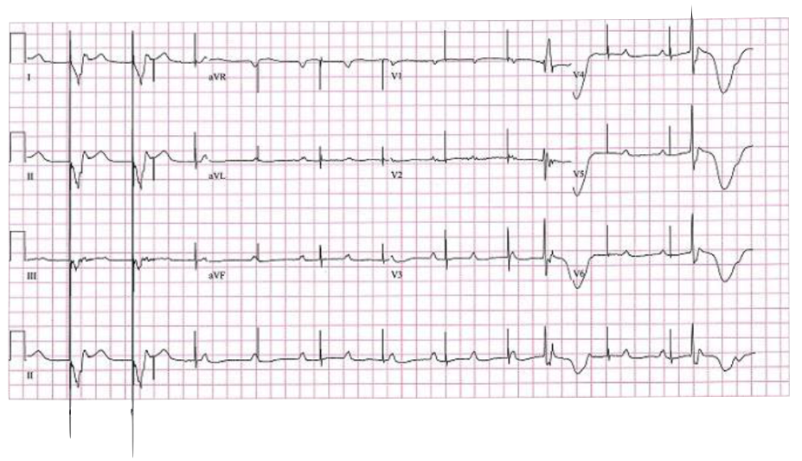

Describe the ECG (5 marks)

Paced rhythm rate 75 bpm
Loss of capture
Period of ventricular standstill
Occasional ventricular ectopic/escape beats
P waves rate 75 – 100 bpm, complete heart block

Name 5 possible causes for this ECG (5 marks)

Lead breakage or displacement causing pacemaker failure
Fibrosis causing pacemaker failure
Electrolyte abnormality
Toxicological causes – Ca channel/B blocker/digoxin toxicity
Failure to capture/needs check of threshold for capture

