New format SAQ 2.

A 35 year old woman presents with palpitations and shortness of breath. On arrival her BP is 70/40. An ECG is taken.

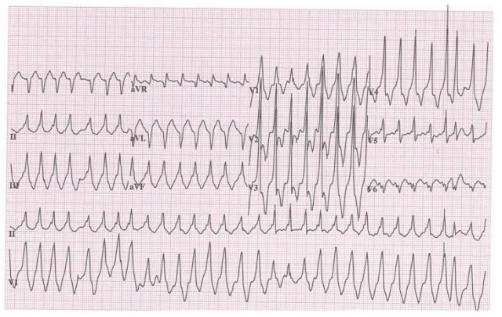

- What are 5 important features of the ECG

- List three possible differential diagnoses

- List important steps in your immediate management

- Rate @ 240, Rhythm irregular (AF),rightward access, Delta waves, / fusion beats in severalleads esp lead 2 and V1

- AF RBBB, WPW with aberrancy, VT, Torsades.

- Resus with full monitoring, supplemetal O2, iV access, fluid bolus, synchronised DC cardioversion 100J with sedation and analgesia

