Broad Complex tachycardia

A 46 year old man is brought to your emergency department by ambulance following an overdose of unknown medications. He has had a brief generalized seizure en route. On arrival his observations are:
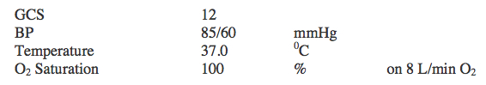
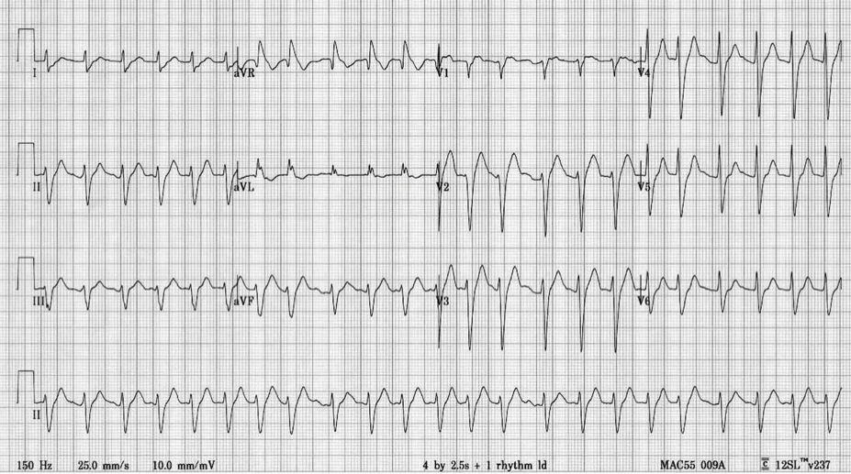

Describe the ECG (5 marks)

What are the first 5 things you would do to manage the patient? (5marks)

