Broad Complex tachycardia

A 46 year old man is brought to your emergency department by ambulance following an overdose of unknown medications. He has had a brief generalized seizure en route. On arrival his observations are:
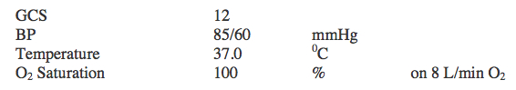
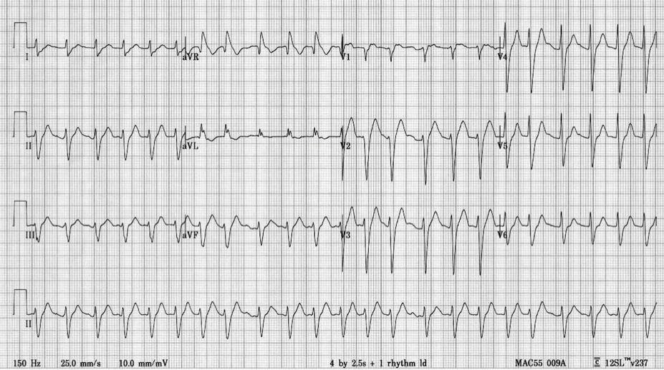

Describe the ECG (5 marks)

    - Rate 150, Axis normal, Rhythm irregular broad complex tachycardia, R Prime AVR ,
    - Interpretation – consistent with Na Channel Blockade
    - QRS upper limit or slightly prolonged,
    - QT almost half the RR along with examples gave extra marks

What are the first 5 things you would do to manage the patient?

    - Mx in resus area, team approach, delegate care of rest of department
    - treatment with NaHCo3 (50 ml 8.4%, repeat to achieve pH 7.5 and QRS <120ms)
    - Fluid Mx for hypotension (1litre 0.9% NaCl stat and repeat if necessary to achieve MAP > 65mmHg)
    - Benzodiazepines for seizures (appropriate dose for agent chosen)
    - RSI and ventilation to low normal CO2

