An elderly man collapses and is unresponsive at a shopping centre. What are the 4 elements in the chain of survival that improve the probability of survival? (2 marks)

He receives prompt BLS from bystanders, then defibrillation from an AED prior to the arrival of the ambulance 10 minutes post-arrest. He is found to be in VF and does not revert with defibrillation by the ambulance crew. He is transported to ED, where he is still pulseless and the monitor shows this rhythm.

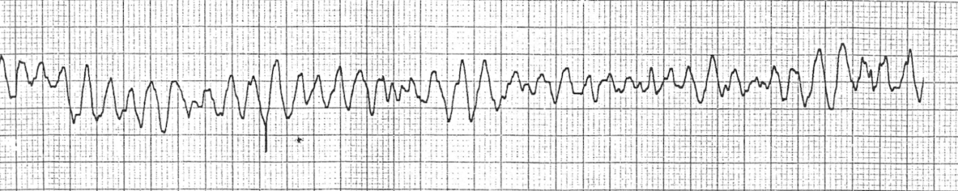

What are your immediate actions? (8 marks)

