An elderly man collapses and is unresponsive at a shopping centre. What are the 4 elements in the chain of survival that improve the probability of survival? (2 marks)

Early access to emergency medical services, BLS, defibrillation and advanced care (0.5 mark for each, accept ambulance/EMS as alternatives to emergency medical services)

From Cameron, Textbook of Adult Emergency Medicine, 2009, p5

He receives prompt BLS from bystanders, then defibrillation from an AED prior to the arrival of the ambulance 10 minutes post-arrest. He is found to be in VF and does not revert with defibrillation by the ambulance crew. He is transported to ED, where he is still pulseless and the monitor shows this rhythm.

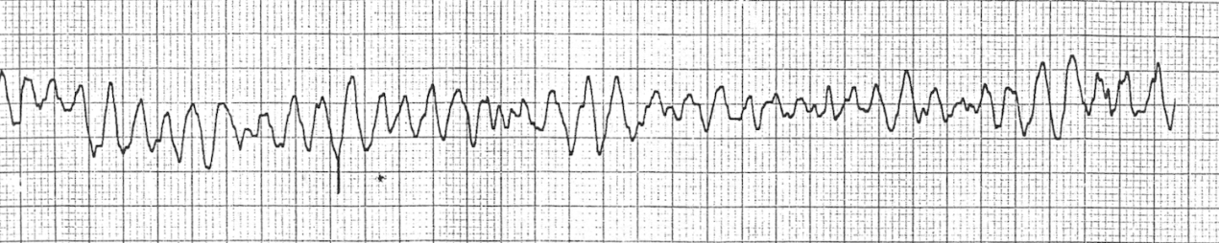

What are your immediate actions? (8 marks)

Assume leadership, delegate roles
Ensure continuous BLS provided throughout
Manual biphasic shock 200J
Continue CPR 2 minutes
During CPR:
Check electrode position
Secure IV access
Adrenaline 1mg and repeat after second shock and every second loop
Correct reversible causes (4Hs,4Ts)
Advanced airway
Amiodarone 300mg after 3rd shock
Post-resuscitation care/12-lead ECG/reperfusion

From ARC Resuscitation guideline, online, accessed 5/8/2014

