New format SAQ 1.

A55 year old woman presents by ambulance. This is her appearance upon arrival in ED

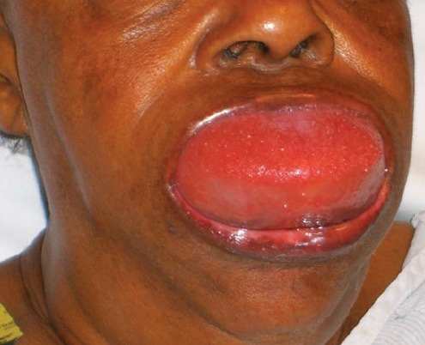

- List three differential diagnoses

- List 5 features of her medical history that are particularly important to enquire about

- State your first 5 management steps

- Angioedema, Anaphylaxis, Trauma (haematoma)

- Allergy history, medication history, family history of similar events, previous episodes and how managed

- Resus with full monitoring, Adrenaline neb(5mg) and/or IM (.3-.5mg), urgent airway call (anaesthetics/ICU), difficult airway and surgical airway kit at bedside, optimise current airway by positioning, IV access, supplemental O₂ if hypoxia

