SAQ
You have been asked by the Head of your Emergency Department to give a presentation on Access Block and the National Emergency Access Target (NEAT).

a. What is the definition of Access Block ? (2 Marks)
This refers to the percentage of patients who were admitted or planned for admission but discharged from the emergency department (ED) without reaching an inpatient bed, transferred to another hospital for admission, or died in the ED whose total ED time exceeded 8 hours, during the 6 month time period. Taken from ACEM Policy on Standard Terminology P02v4 March 2009

1 Mark for recognising proportion / percentage of patients who do not reaching in-patient bed
1 Mark for accurate time frame of exceeding 8 hours

b. What is the National Emergency Access Target ? (2 Marks)
The National Emergency Access Target requires that by 2015, 90% of all patients presenting to a public hospital Emergency Departments will be admitted, transferred or discharged within four hours - Applies to all of Australia. Taken from WA Government Emergency Access Reform Web Site.
NOTE - New Zealand Access Time Target is 95% within six hours.

1 Mark for correct percentage of patients to be admitted.
1 Mark for correct time frame of within 4 hours.

b. Outline potential solutions to improving Access Block & Overcrowding (6 Marks)
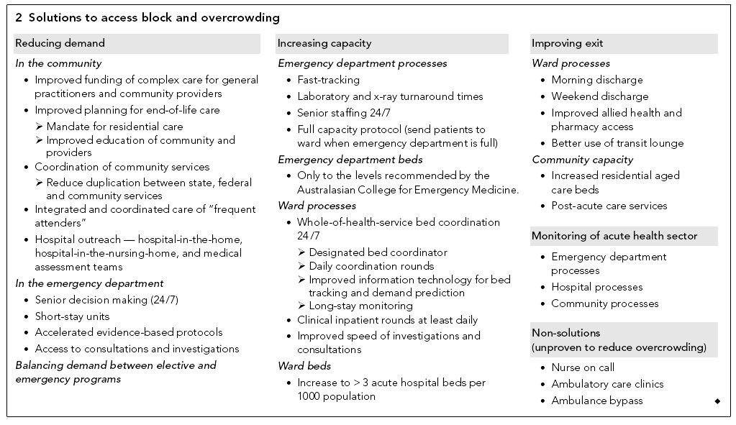
1 Mark per entry to maximum of 6 marks- a maximum of 3 marks can be given for Emergency Department specific strategies i.e. for full marks must include minimum of 3 hospital or community based strategies. Table taken from Cameron PA, Joseph AP, McCarthy SM. Access block can be managed. MJA 190;7:364-368. April 2009.

