ACEM Fellowship Written_Resuscitation/Anaesthetics

Feb 19 2019_Rebecca Day

Hot Topics in The Tropics
RSI
LMA
High flow
CICO and Surgical Airways
Protective (ARDS) vs Obstructive Ventilation Strategies
Non Invasive Ventilation ? high flow
Cardiac Arrest
Special situations – trauma/preg/paed/hypothermia
Central Lines
Inotropes
Age Specific Differences
Local Anaesthetic Blocks
Procedural Sedation

Q1 (20 marks)
A 40kg 13 years old female presents in extremis with severe asthma. She has been treated with ventolin, atrovent, hydrocortisone, MgSo4 and IM adrenaline 500mcg SC. She has had several ICU admissions previously and has been ventilated twice. She requires urgent intubation in ED

Sats 78% on 8L O2 driven nebuliser
RR 50 shallow
P 40
Temp 36.7
BP 70/50
GCS 8

a. In the table below, list 4 potential peri-intubation complications that you may encounter in this patient and 2 measures you will take to minimise the likelihood or effect of each (12 marks)

Complication | Measure 1 | Measure 2

After the patient is intubated and commenced on SIMV-PS ventilation on an oxylog ventilator, the nurse asks you what ventilator settings you would like

b. List four (4) ventilator settings you will utilise for the first few mins post intubation before reassessing (4 marks)

______________________________________________________________________________________________________________________________________________________________________________
_______________________________________________________________________________________
_______________________________________________________________________________________

Shortly after you commence ventilation the nurse tells you that the systolic BP is 60

c. List 4 potential reasons for this (4 marks)

_______________________________________________________________________________________
_______________________________________________________________________________________
_______________________________________________________________________________________
_______________________________________________________________________________________

Q2 (marks)
A 10 month old child who weighs 9kg presents with breathing difficulties and fever, the presentation is entirely consistent with bronchiolitis. They were commenced on 4L simple nasal prong oxygen for increased work of breathing and saturations on air of 88%. They are grunting and have unable to feed properly for 2 days due to incresased work of breathing

RR 70
P 170
Temp 37.8
BP 80/50
Sats 89%

a. List the two (2) next appropriate therapies that you will commence now in this child with brief details of each (4 marks)

Therapy | Details

A CXR has been performed by the GP in the pre-hospital phase.

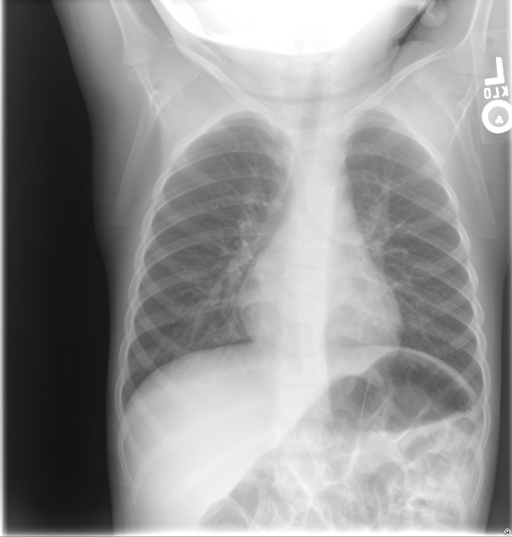

b. List 1 abnormal features on this XRay (1 marks)

_______________________________________________________________________________________
_______________________________________________________________________________________

The emergency buzzer is pressed in the resus room. The child is having a tonic clonic seizure in the context of a fever of 38.9C

c. List the 3 initial actions or instructions you will perform when entering the resus room (3 marks)

_______________________________________________________________________________________
_______________________________________________________________________________________
_______________________________________________________________________________________
_______________________________________________________________________________________

The parents ask what they should do if a seizure ever occurs at home.

d. List four (4) instructions or pieces of information you normally give to the parents about febrile seizures, assuming they will not be provided with benzodiazepine for home administration (3 marks)

_______________________________________________________________________________________
_______________________________________________________________________________________
_______________________________________________________________________________________
_______________________________________________________________________________________

Q3 (14 marks)
You are called in from home to assist the sole overnight junior registrar with a difficult intubation in a rural centre. A 34 year old man has been hit in the face and chest with a baseball bat and requires emergent intubation. There are no additional airway trained doctors to assist you and the retrieval service are 90 minutes away

GCS 3
BP 100/60
P 110
Sats 90% RA
RR 13
T 37.2

a. In the table below list your stepwise intubation plan for this patient assuming failure at each attempt due to inadequate laryngeal view, and slowly deteriorating saturations despite bag valve mask ventilation. Provide brief details of each stage (8 marks)

Attempt 1
Attempt 2
Attempt 3
Attempt 4

The patient is safely intubated. The retrieval service are 30 mins away. There is no CT scanner in your centre. The patient becomes bradycardic and hypertensive.

b. List the two (2) most important immediate management steps (2 marks)

_______________________________________________________________________________________
_______________________________________________________________________________________

c. List four (4) other neuroprotective measures you will undertake (4 marks)

_______________________________________________________________________________________
_______________________________________________________________________________________
_______________________________________________________________________________________
_______________________________________________________________________________________

Q4 (12 marks)
A pregnant female has been involved in a single car accident. Her car was seen to lose control on a bend and hit a tree at an approximate speed of 60kmhr. She has obvious head and chest injuries.

P 130
BP 60/40
Sats 90% 6L Hudson
RR 34
GCS 6
Temp 36.7

a. List four (6) important considerations when assessing and managing this pregnant female vs a similar but non-pregnant female (6 marks)

_______________________________________________________________________________________
_______________________________________________________________________________________
_______________________________________________________________________________________
_______________________________________________________________________________________
_______________________________________________________________________________________
_______________________________________________________________________________________

The patient has a trauma series of X-Rays and subsequently suffers a cardiac arrest 5 minutes after arrival. She has already been intubated by the ED registrar.

b. List the three (3) immediate interventions or treatments you plan to administer (3 marks)
______________________________________________________________________________________________________________________________________________________________________________
_______________________________________________________________________________________

The patients chest X Ray is shown

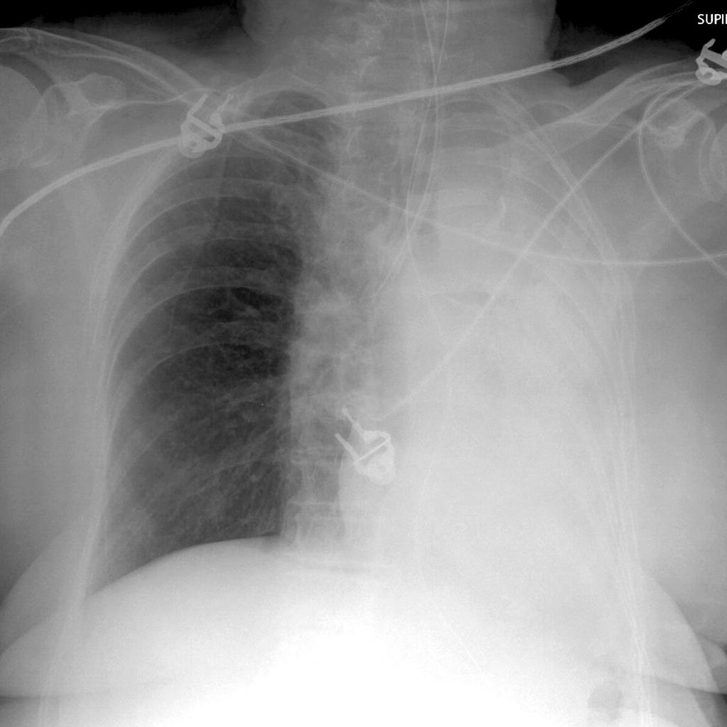

c. List three (3) abnormal features on this CXR (3 marks)

______________________________________________________________________________________________________________________________________________________________________________
_______________________________________________________________________________________

Q5 (10 marks)
A 69 years old male has been found unconscious outside of a pub at 4am. He was last seen heavily intoxicated leaving the pub at 11pm. There are no signs of external trauma

P 40 (atrial fibrillation on monitor)
BP 60/40
Sats 97% on 15L NRB
RR 8
T 26C (Rectal)
GCS 6

VBG (uncorrected values for temperature)
pH 7.1
pCO2 69
HCO3 15
Gluc 2.3
Lact 4.5
Na 145
K 5.1
Cr 230

a. In the table below list four (4) immediate management priorities in this patient with brief details of each (8 marks)

Management Priority | Details

The patient has a VF arrest during the first 5 minutes in ED

b. List 2 modifications you will make to the standard ALS algorithm in this patient (2 marks)

_______________________________________________________________________________________
_______________________________________________________________________________________

Q6 (21 marks)
A 4 year old boy is brought to your Emergency Department having sustained a 4 cm full thickness eyebrow laceration following a fall at a playground.

You plan to suture the wound under procedural sedation using ketamine. You have introduced yourself to the mother and examined the child.

a. List four (4) contraindications to ketamine use in this setting? (4 Marks)

_______________________________________________________________________________________
_______________________________________________________________________________________
_______________________________________________________________________________________
_______________________________________________________________________________________

b. List 6 essential pieces of information (other than contraindications) that you will cover with the parent during consent for this procedure (6 marks)

_______________________________________________________________________________________
_______________________________________________________________________________________
_______________________________________________________________________________________
_______________________________________________________________________________

c. Complete the following table regarding ketamine usage in paediatric procedural sedation by route of delivery (8 Marks)

 | Intra-muscular (i.m) | Intra-venous (i.v)
Initial dose
Top-up dose
Advantage
Disadvantage

The child suffers laryngospasm at the commencement of the procedure, which is immediately ceased.

d. List the 3 stepwise actions you will take to address this complication (3 marks)

_______________________________________________________________________________________
_______________________________________________________________________________________
_______________________________________________________________________________________

Q7 (12 marks)

You are called in overnight by a junior registrar to help with the management of a 39 year old man with cellulitis. He presented 2 hrs ago with swollen, painful legs and a fever. He has been unwell for 3 days. He has a history of type 1 diabetes and harmful alcohol use. No history of trauma or burns. A clinical photo is shown

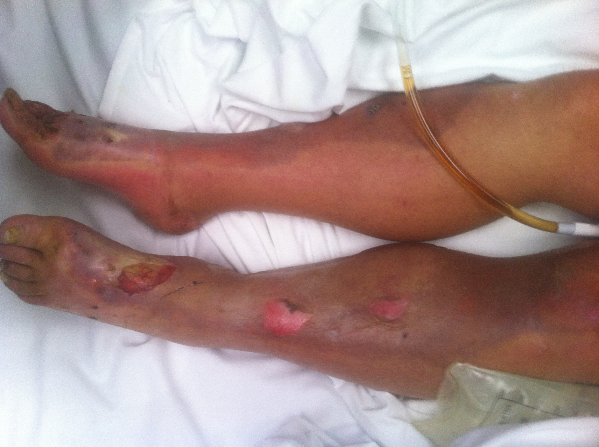

P 130
BP Initially 100/60, now 70/40
RR 32
Temp 39.4
Sats 99% RA
GCS 13

Urine dip positive for red cells only

pH 7.12
pCO2 45
HCO3 12
Lact 5.6
K 6.7
BSL 39

WCC 21
Hb 89
Creat 540

He has received 4L of NaCl 0.9% in the last 2 hrs and a single dose of IV flucloxacillan 1g
3 sets blood cultures and wound swabs sent

a. In the table below list your six (6) immediate priorities with brief details of each (12 marks)

Priority | Details

Q8 (11 marks)
A 67 years old female has a colles fracture that requires reduction on ED for neurovascular compromise. The registrar has taken the patient to the resus room to perform a Biers Block.

You are called 5 mins into the procedure to assist as there has been a clinical error that led to inappropriately early cuff deflation at 4mins post 0.5% prilocaine injection of 0.5ml/kg

The patient became rapidly confused and is now hypotensive

P 120
BP 60/40
Sats 89% RA
RR 26
Temp 37.0

Her ECG is shown

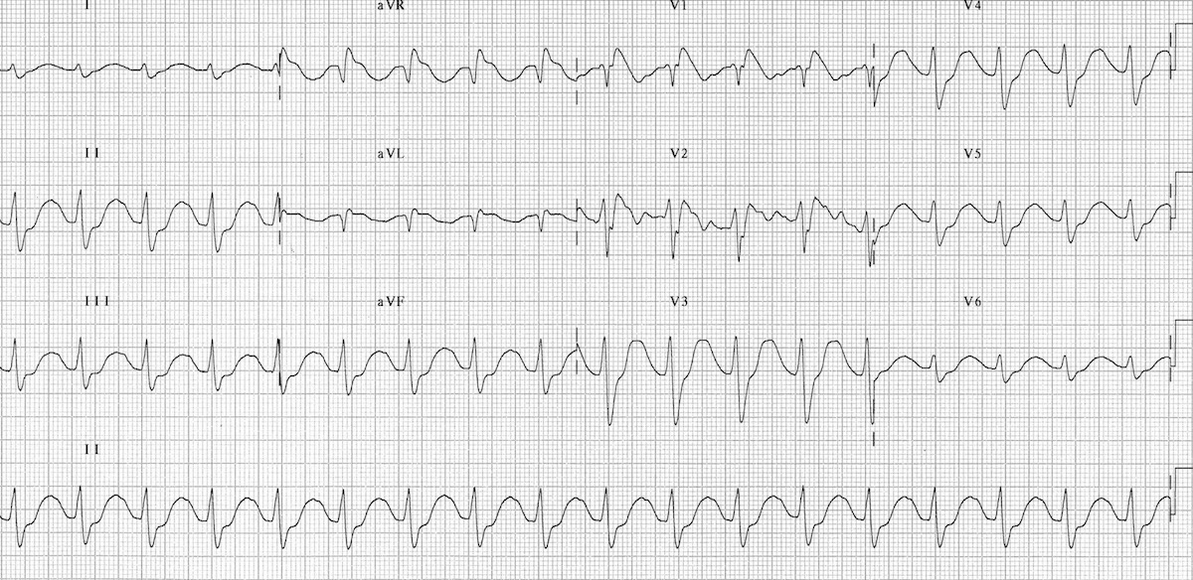

a. List four (4) abnormal features in this ECG (4 marks)

_______________________________________________________________________________________
_______________________________________________________________________________________
_______________________________________________________________________________________
_______________________________________________________________________________________

A second ECG 2 minutes later is also shown
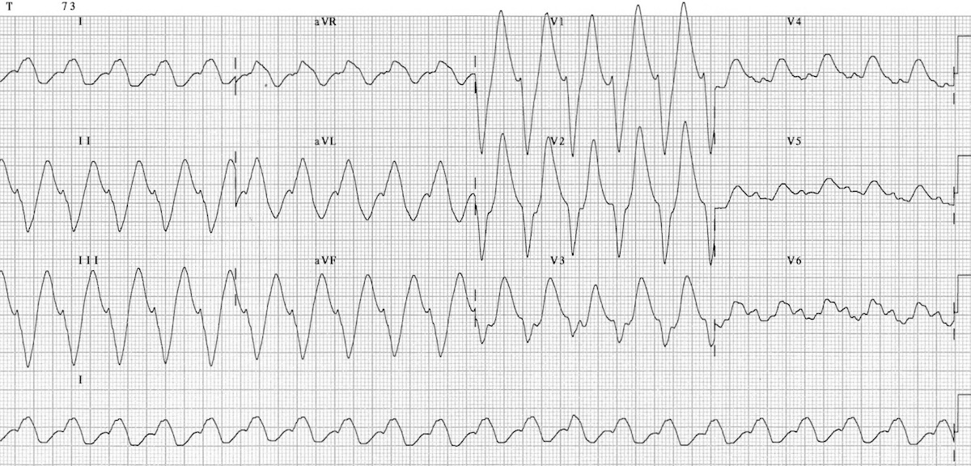

b. List the 5 steps you will take in managing this patient assuming no clinical improvement at each stage (5 marks)

_______________________________________________________________________________________
_______________________________________________________________________________________
_______________________________________________________________________________________
_______________________________________________________________________________________
_______________________________________________________________________________________
_______________________________________________________________________________________

c. List the further complication of local anaesthetic toxicity that you predict may occur in this patient and the medication you will prepare for that eventuality (2 marks)

_______________________________________________________________________________________
_______________________________________________________________________________________

Q9 (14 marks)

It is 2 am and you are on call for a rural emergency department. You are the only available doctor with advanced airway skills.

You have been called in from home to assist the junior registrar with a 1 years old boy who presented with stridor and acute respiratory distress 1 hour ago. The registrar has already treated for presumed croup with 3 rounds of adrenaline nebulisers, and dexamethasone 0.3mk/kg. There are 2 patent IV access. The child is deteriorating, has rest stridor and appears exhausted. There is no option for immediate transfer to theatres or elsewhere. The paediatric retrieval service will arrive in 1 hour.

Weight 15kg

P 150
Sats 86% on 10L O2 driven nebuliser
RR 60
BP 80/40
Temp 38.2

pH 7.02
pCO2 60
pO2 21
HCO3 14
Lact 3.2

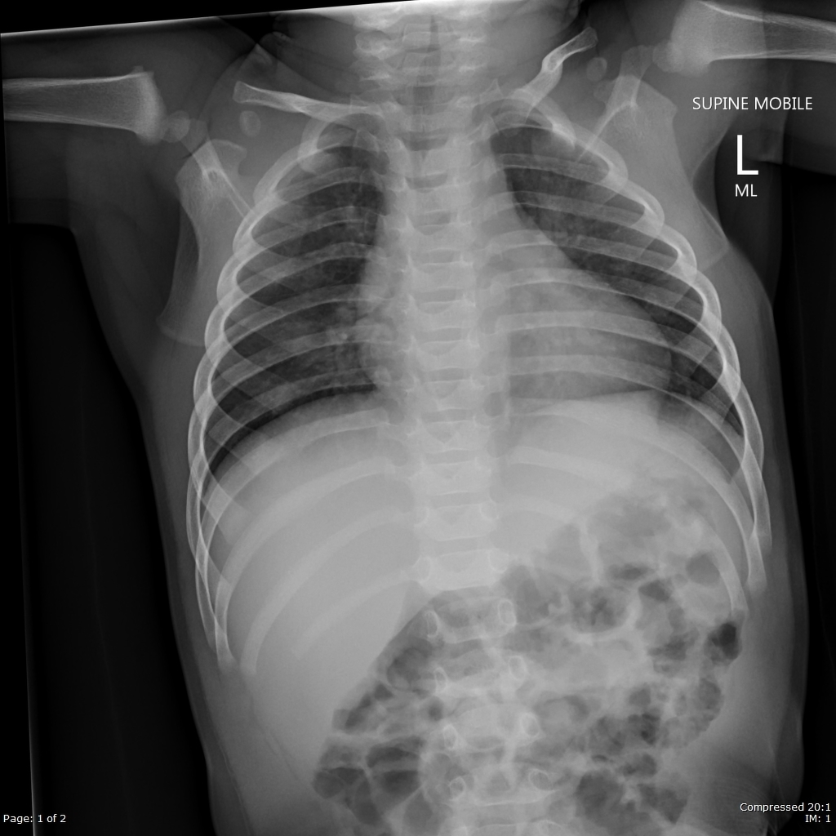

a. State the most relevant finding on the CXR (1 Mark)

_______________________________________________________________________________________

b. List three (3) potential complications during this intubation, and two (2) pre-emptive actions you will take to address each potential complication. (9 Marks)

Complication | Action 1 | Action 2

After your 3 best attempts at oral endotracheal intubation you are unable to secure the airway. The child has saturations of 79% that are not responding to BVM ventilation. There is no fibre optic scope in your rural ED.

c. List the 4 most important steps, with brief details of each, in your Failed Intubation Plan (4 Marks)

_______________________________________________________________________________________
_______________________________________________________________________________________
_______________________________________________________________________________________
_______________________________________________________________________________________

