ACEM Fellowship Written_Resuscitation/Anaesthetics

Feb 19 2019_Rebecca Day

Hot Topics in The Tropics
RSI
LMA
? high flow
CICO and Surgical Airways
Protective (ARDS) vs Obstructive Ventilation Strategies
Non Invasive Ventilation ? high flow
Cardiac Arrest
Special situations – trauma/preg/paed/hypothermia
Central Lines
Inotropes
Age Specific Differences
Local Anaesthetic Blocks
Procedural Sedation

Q1 (20 marks)
A 40kg 13 years old female presents in extremis with severe asthma. She has been treated with ventolin, atrovent, hydrocortisone, MgSo4 and IM adrenaline 500mcg SC. She has had several ICU admissions previously and has been ventilated twice. She requires urgent intubation in ED

Sats 78% on 8L O2 driven nebuliser
RR 50 shallow
P 40
Temp 36.7
BP 70/50
GCS 8

a. In the table below, list 4 potential peri-intubation complications that you may encounter in this patient and 2 measures you will take to minimise the likelihood or effect of each (12 marks)

Complication | Measure 1 | Measure 2

Complication | Measure 1 | Measure 2
Hypoxia | Pre intubation BiPaP  15L via NRB | Keep upright until induction drugs given
Hypercarbia/Acidosis | Bag through intubation | Bicarb if critical acisosis
Hypotension | Fluid loading, NaCl Stat 1L | Push dose pressors e.g. 50mcg adrenaline, or start NAd IVI 5-20mcg/min
PTX | Avoid overzealous BVM after intubation | Minimise PIP/Pplat when ventilating.
Cardiac Arrest | Predrawn adrenaline, pads on patient | Prep team for likelihood of arrest
Failure to secure airway | Mark neck for surgical airway | Involve anaesthetic and ICU team to ensure experienced second intubator

After the patient is intubated and commenced on SIMV-PS ventilation on an oxylog ventilator, the nurse asks you what ventilator settings you would like

b. List four (4) ventilator settings you will utilise for the first few mins post intubation before reassessing (4 marks)

______________________________________________________________________________________________________________________________________________________________________________
_______________________________________________________________________________________
_______________________________________________________________________________________

RR 8
FIO2 1.0
PEEP 0 (max of 5)
Vt 240mls (6 mls/kg)
PS 10-15

Shortly after you commence ventilation the nurse tells you that the systolic BP is 60

c. List 4 potential reasons for this (4 marks)

_______________________________________________________________________________________
_______________________________________________________________________________________
_______________________________________________________________________________________
_______________________________________________________________________________________

Breath stacking
Intubation drugs and increased
Dehydration/Insensible losses
PTX
Anaphylaxis to drugs

Q2 (marks)
A 10 month old child who weighs 9kg presents with breathing difficulties and fever, the presentation is entirely consistent with bronchiolitis. They were commenced on 4L simple nasal prong oxygen for increased work of breathing and saturations on air of 88%. They are grunting and have unable to feed properly for 2 days due to incresased work of breathing

RR 70
P 170
Temp 37.8
BP 80/50
Sats 89%

a. List the two (2) next appropriate therapies that you will commence now in this child with brief details of each (4 marks)

Therapy | Details

High flow nasal prong O2 1-2L/kg humidified – short trial with escalation to invasive resp support if deteriorating
(OR CPAP 5-10, BiPap 10/5, FIO2 titrated to sats >91%)
(OR Intubation, size 3.5-4 ETT, Vt 48mls, PEEP 5-10, FIO2 titrated to sats >91%)

Fluids
2/3 to full maintainence – 0.9%NaCl + 5% dextrose 24mls/hr – 36mls/hr

(antibiotics/steroids/nebulisers all incorrect in the setting of likely bronch)

A CXR has been performed by the GP in the pre-hospital phase.

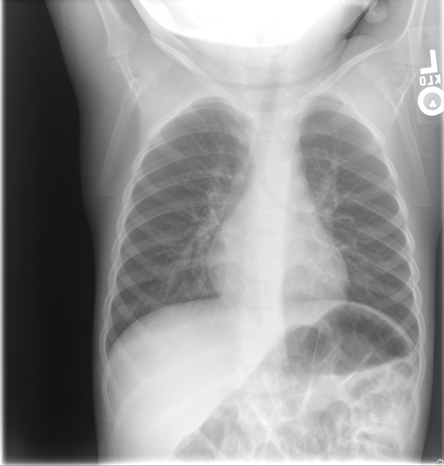

b. List 1 abnormal features on this XRay (1 marks)

_______________________________________________________________________________________
_______________________________________________________________________________________

Peribronchial thickening
Perihilar infiltrates

The emergency buzzer is pressed in the resus room. The child is having a tonic clonic seizure in the context of a fever of 38.9C

c. List the 3 initial actions or instructions you will perform when entering the resus room (3 marks)

_______________________________________________________________________________________
_______________________________________________________________________________________
_______________________________________________________________________________________
_______________________________________________________________________________________

Support airway and oxygenation – positioning, O2, airway opening manoeuvres, suction
(may state if started CPAP or high flow that may change to BVM)
Check a BSL
Ask for 0.15mg/kg IV or IM midazolam to be drawn up in the event that seizure doesn’t self terminate
(or Buccal/intranasal 0.3mg/kg)

The parents ask what they should do if a seizure ever occurs at home.

d. List four (4) instructions or pieces of information you should give to the parents about febrile seizures, assuming they will not be provided with benzodiazepine for home administration (3 marks)

_______________________________________________________________________________________
_______________________________________________________________________________________
_______________________________________________________________________________________
_______________________________________________________________________________________

- One in 30 children have a febrile convulsion at one time or another, usually between the ages of six months and six years.
- Simple febrile seizures do not indicate a child will have ongoing epilepsy
- Can recur, the younger the child the greater the risk 1yr=50%, 2yr=30%
- Nothing can be done to prevent a febrile convulsion from occurring.
- Put the child on their back or side or a soft surface, e.g. bed
- During a convulsion, remain calm and try not to panic. Do not put your child in a bath, restrain them, or put anything in their mouth.
- Febrile convulsions are not harmful to your child, and will not cause brain damage.
- If the convulsion lasts more than five minutes call an ambulance.
- If the convulsion lasts less than five minutes and your child was very unwell before the convulsion, take them to the GP or hospital emergency department as soon as possible. Otherwise, make an appointment to see your GP.

Q3 (14 marks)
You are called in from home to assist the sole overnight junior registrar with a difficult intubation in a rural centre. A 34 year old man has been hit in the face and chest with a baseball bat and requires emergent intubation. There are no additional airway trained doctors to assist you and the retrieval service are 90 minutes away

GCS 3
BP 100/60
P 110
Sats 90% RA
RR 13
T 37.2

a. In the table below list your stepwise intubation plan for this patient assuming failure at each attempt due to inadequate laryngeal view, and slowly deteriorating saturations despite bag valve mask ventilation. Provide brief details of each stage (8 marks)

Attempt 1
Attempt 2
Attempt 3
Attempt 4

Attempt 1 | RSI, ketamine and roc, ETT 8.0, Bougie, VL, double suction
Attempt 2 | Reposition, BURP, ELM, alternate blade e.g McCoy
Attempt 3 | LMA, other supraglottic
Attempt 4 | Cricothyroidotomy either Cook or scalpel bougie FONA

(Other variations on this are appropriate)

The patient is safely intubated. The retrieval service are 30 mins away. There is no CT scanner in your centre. The patient becomes bradycardic and hypertensive.

b. List the two (2) most important immediate management steps (2 marks)

_______________________________________________________________________________________
_______________________________________________________________________________________

Aggressive hyperventilation to low CO2 <35 to redude ICP via vasoconstriction
Hypertonic saline 3mls/kg or Mannitol 1g/kg
?Burr Hole is appropriately skilled

c. List four (4) other neuroprotective measures you will undertake (4 marks)

_______________________________________________________________________________________
_______________________________________________________________________________________
_______________________________________________________________________________________
_______________________________________________________________________________________

Head Up 30 degrees
Well sedated and paralysed
Tape not tie the ETT
Good oxygenation FIO2 1.0

Q4 (12 marks)
A pregnant female has been involved in a single car accident. Her car was seen to lose control on a bend and hit a tree at an approximate speed of 60kmhr. She has obvious head and chest injuries.

P 130
BP 60/40
Sats 90% 6L Hudson
RR 34
GCS 6
Temp 36.7

a. List four (6) important considerations when assessing and managing this pregnant female vs a similar but non-pregnant female (6 marks)

_______________________________________________________________________________________
_______________________________________________________________________________________
_______________________________________________________________________________________
_______________________________________________________________________________________
_______________________________________________________________________________________
_______________________________________________________________________________________

Consider differing obs e.g. lower BP/higher Vt/tachycardia/masking of shock
Lab parameters may differ e.g. physiological anaemia, resp alkalosis expected
Anticipate faster desat due to lower FRC
Anticipate higher risk of aspiration – double suction
Anticipate difficult airway due to oedema/habitus/breasts
Left lateral tilt/manual displacement of uterus
Avoidance of teratogenic medications
Consideration of emergenct CS or resuscitative hysterotomy
Consideration of uterine rupture/abruption
More difficult FAST scan
Administer AntiD/Kleihauer test
Arrange urgent CTG/O&G input

The patient has a trauma series of X-Rays and subsequently suffers a cardiac arrest 5 minutes after arrival. She has already been intubated by the ED registrar.

b. List the three (3) immediate interventions or treatments you plan to administer (3 marks)
______________________________________________________________________________________________________________________________________________________________________________
_______________________________________________________________________________________

Blood product replacement pre MTP principles – O negative blood
Bilateral thoracostomy
Manual displacement of the uterus (only allowed if not mentioned in the above question)
Resuscitative hysterotomy (ideally within 4 mins of arrest to maximise fetal survival)

The patients chest X Ray is shown

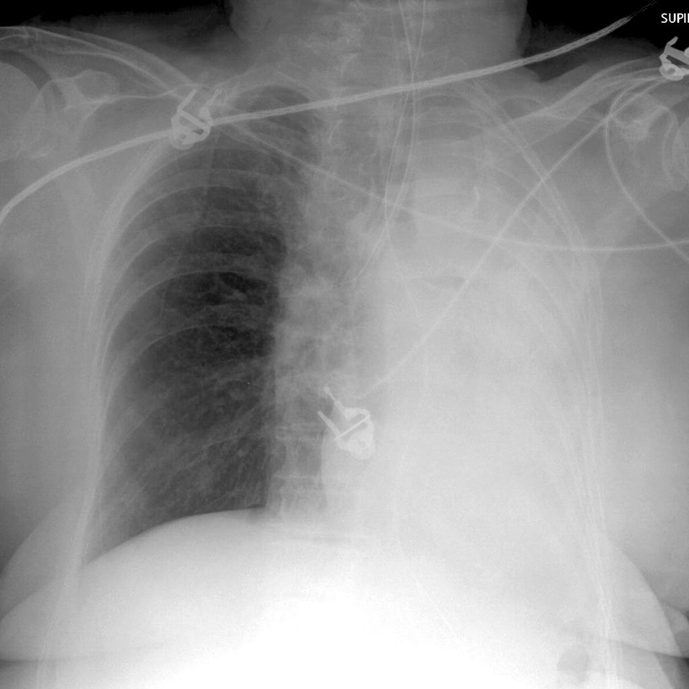

c. List three (3) abnormal features on this CXR (3 marks)

______________________________________________________________________________________________________________________________________________________________________________
_______________________________________________________________________________________

Right main bronchus intubation
Collapse of left lung
Mediastinal shift to the left

Q5 (10 marks)
A 69 years old male has been found unconscious outside of a pub at 4am. He was last seen heavily intoxicated leaving the pub at 11pm. There are no signs of external trauma

P 40 (atrial fibrillation on monitor)
BP 60/40
Sats 97% on 15L NRB
RR 8
T 26C (Rectal)
GCS 6

VBG (uncorrected values for temperature)
pH 7.1
pCO2 69
HCO3 15
Gluc 2.3
Lact 4.5
Na 145
K 5.1
Cr 230

a. In the table below list four (4) immediate management priorities in this patient with brief details of each (8 marks)

Management Priority | Details

Management Priority | Details
Warming – external passive and internal active | Remove cold wet clothes  Humidified warm air and warmed fluids  Bair hugger  All cavity warming – IDC/NG/ICC/Peritoneal  ECMO/Bypass/Haemofilter etc
Correction of Hypoglycaemia | 50mls 50% dextrose
Inotropy/Pressors/Fluids for BP/P | Via central line  Noradrenaline/Adrenaline titrated to
Airway Protection | RSI - preox/apnoeic ox/ketamine 1-2mg.kg/Roc 1.2 mg/kg/ETT 8.0

The patient has a VF arrest during the first 5 minutes in ED

b. List 2 modifications you will make to the standard ALS algorithm in this patient (2 marks)

_______________________________________________________________________________________
_______________________________________________________________________________________

No drugs below 30 degrees then double the interval till 35 degrees
3 shocks for VF then if no effect withhold till temp >30
Aggressive rewarming as priority

Q6 (21 marks)
A 4 year old boy is brought to your Emergency Department having sustained a 4 cm full thickness eyebrow laceration following a fall at a playground.

You plan to suture the wound under procedural sedation using ketamine. You have introduced yourself to the mother and examined the child.

a. List four (4) contraindications to ketamine use in this setting? (4 Marks)

_______________________________________________________________________________________
_______________________________________________________________________________________
_______________________________________________________________________________________
_______________________________________________________________________________________

Parental refusal
Procedural required unsuitable for ketamine sedation
Inadequate staffing / area / equipment
Previous adverse reaction to Ketamine
Altered conscious state
Unstable patient: seizures, vomiting, hypotension
Cardiovascular disease - heart failure, uncontrolled hypertension, congenital heart disease
Procedures involving stimulation of posterior pharynx
Known airway instability or tracheal abnormality
Psychosis
Thyroid disorder or medication
Porphyria
Risk of raised intraocular or intracranial pressure
Active pulmonary infection or disease including acute asthma and URTI
Full meal within 3 hours (relative contraindication only, balance risk against urgency of procedure)

b. List 6 essential pieces of information (other than contraindications) that you will cover with the parent during consent for this procedure (6 marks)

_______________________________________________________________________________________
_______________________________________________________________________________________
_______________________________________________________________________________________
_______________________________________________________________________________________

What to expect
Dissociation – eye movements, noises, staring, emergence
IV vs IM/procedural steps

Possible complications:
Airway obstruction
Nystagmus
Muscle rigidity
Random movements (can resemble seizure like activity)
Vomiting (during or after procedure)
Emergence phenomena
Apnoea
Failed procedure (need for a General Anaesthesia)
Hypersalivation

Recovery time
Alternative Options

Suture information
How long/who removes
Risk of infection and signs to watch out for

Any Questions

c. Complete the following table regarding ketamine usage in paediatric procedural sedation by route of delivery (8 Marks)

 | Intra-muscular (i.m) | Intra-venous (i.v)
Initial dose
Top-up dose
Advantage
Disadvantage

 | Intra-muscular (i.m) | Intra-venous (i.v)
Initial dose | 4 mg/kg | 1 - 1.5 mg/kg
Top-up dose | 2 mg/kg | 0.5 mg/kg
Advantage | Nil iv required, as safe as iv  Longer action etc. | More predictable, easier top-up, quicker onset etc.
Disadvantage | Pain / distress on injection, less predictable etc. | iv line required, quicker offset etc.

The child suffers laryngospasm at the commencement of the procedure, which is immediately ceased.

d. List the 3 stepwise actions you will take to address this complication (3 marks)

_______________________________________________________________________________________
_______________________________________________________________________________________
_______________________________________________________________________________________

Positive pressure ventilation – BVM with PEEP valve fully closed or anaesthetic circuit bag
Larsons Point pressure
Paralytic with intubation

Q7 (12 marks)

You are called in overnight by a junior registrar to help with the management of a 39 year old man with cellulitis. He presented 2 hrs ago with swollen, painful legs and a fever. He has been unwell for 3 days. He has a history of type 1 diabetes and harmful alcohol use. No history of trauma or burns. A clinical photo is shown

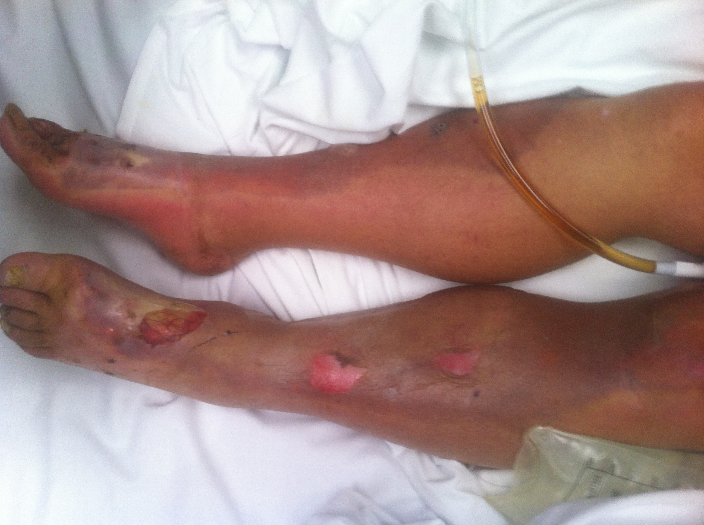

P 130
BP Initially 100/60, now 70/40
RR 32
Temp 39.4
Sats 99% RA
GCS 13

Urine dip positive for red cells only

pH 7.12
pCO2 45
HCO3 12
Lact 5.6
K 6.7
BSL 39

WCC 21
Hb 89
Creat 540

He has received 4L of NaCl 0.9% in the last 2 hrs and a single dose of IV flucloxacillan 1g
3 sets blood cultures and wound swabs sent

a. In the table below list your six (6) immediate priorities with brief details of each (12 marks)

Priority | Details

Priority | Details/Rationale
Urgent Surgical Consult | Most senior surgeon available for debridement of presumed necrostising fasciitis
Antibiotics IV | Broad spectrum  Lincomycin 600mg/Vancomycin 25mg/kg/Meropenum 1g per eTG
Inotropes/Pressors | Push dose metaraminol  Noardenaline started 5mcg/min and titrated to MAP 70 – can start peripheral but will need CVC and Aline
Correction of K | Calcium Gluconate/Insulin infusion/Salbutamol +/- Bicarb
Management of hyperglycamia/DKA | Check Ketones, insulin infusion per protocol, BSL down by max 5 mmol/L/hr, ketones by 3/hr
Contact ICU | Likely to need RRT for rhabdo/sepsis and ventilation/inotropes post debridement.
?Airway protection | Not an imminent priority as GCS and sats ok – if stated must be with a proviso that haemodynamic stabilisation is essential prior to admin of induction agents

Q8 (11 marks)
A 67 years old female has a colles fracture that requires reduction on ED for neurovascular compromise. The registrar has taken the patient to the resus room to perform a Biers Block.

You are called 5 mins into the procedure to assist as there has been a clinical error that led to inappropriately early cuff deflation at 4mins post 0.5% prilocaine injection of 0.5ml/kg

The patient became rapidly confused and is now hypotensive

P 120
BP 60/40
Sats 89% RA
RR 26
Temp 37.0

Her ECG is shown

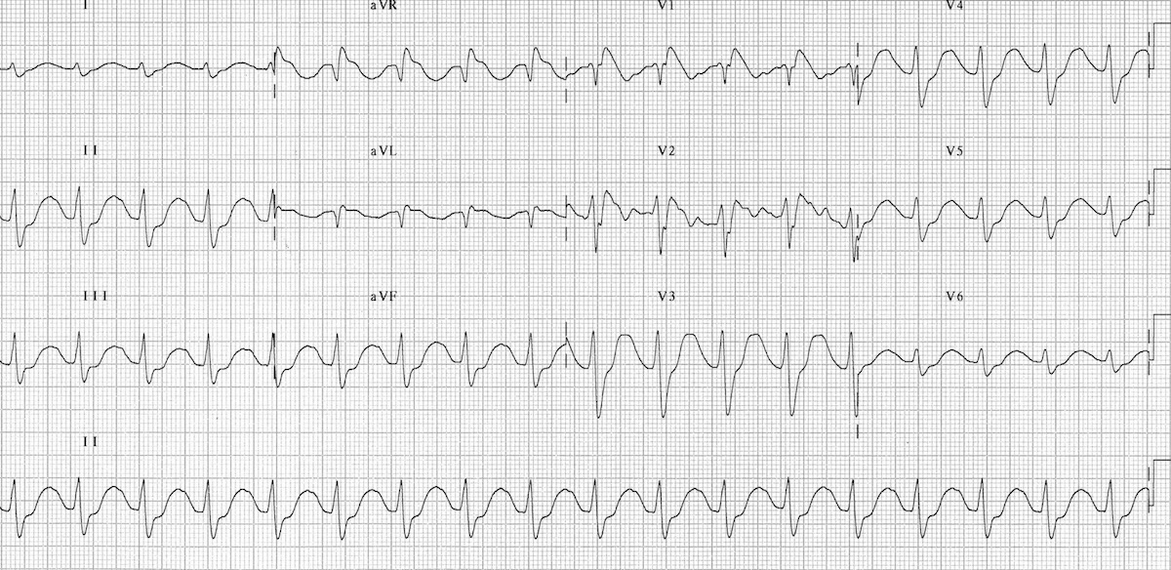

a. List four (4) abnormal features in this ECG (4 marks)

_______________________________________________________________________________________
_______________________________________________________________________________________
_______________________________________________________________________________________
_______________________________________________________________________________________

Broad complex tachycardia 100bpm pprox.
Large R wave in aVR 5mm
Long QTc
First degree HB

A second ECG 2 minutes later is also shown
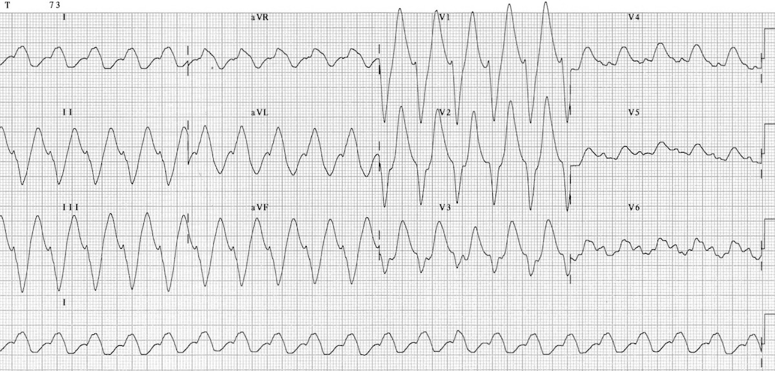

b. List the 5 steps you will take in managing this patient assuming no clinical improvement at each stage (5 marks)

_______________________________________________________________________________________
_______________________________________________________________________________________
_______________________________________________________________________________________
_______________________________________________________________________________________
_______________________________________________________________________________________
_______________________________________________________________________________________

Bicarbonate 8.4% 100mls slow push over 1 min – repeated till QRS duration <100
IV fluids 1000L Stat NaCl
Metaraminol 1mg boluses titrated to BP
Noradrenaline Infusion
Intralipid 1-1.5mls/kg (repeated up to twice further), then infusion of 0.25mls/kg/min, then 0.5mls/kg/min if ongoing hypotension. Max total dose 8mls/kg
Oxygen therapy 15L NRB

c. List the further complication of local anaesthetic toxicity that you predict may occur in this patient and the medication you will prepare for that eventuality (2 marks)

_______________________________________________________________________________________
_______________________________________________________________________________________

Seizures
Midazolam 10mg IV

Q9 (marks)

It is 2 am and you are on call for a rural emergency department. You are the only available doctor with advanced airway skills.

You have been called in from home to assist the junior registrar with a 1 years old boy who presented with stridor and acute respiratory distress 1 hour ago. The registrar has already treated for presumed croup with 3 rounds of adrenaline nebulisers, and dexamethasone 0.3mk/kg. There are 2 patent IV access. The child is deteriorating, has rest stridor and appears exhausted. There is no option for immediate transfer to theatres or elsewhere. The paediatric retrieval service will arrive in 1 hour.

Weight 15kg

P 150
Sats 86% on 10L O2 driven nebuliser
RR 60
BP 80/40
Temp 38.2

pH 7.02
pCO2 60
pO2 21
HCO3 14
Lact 3.2

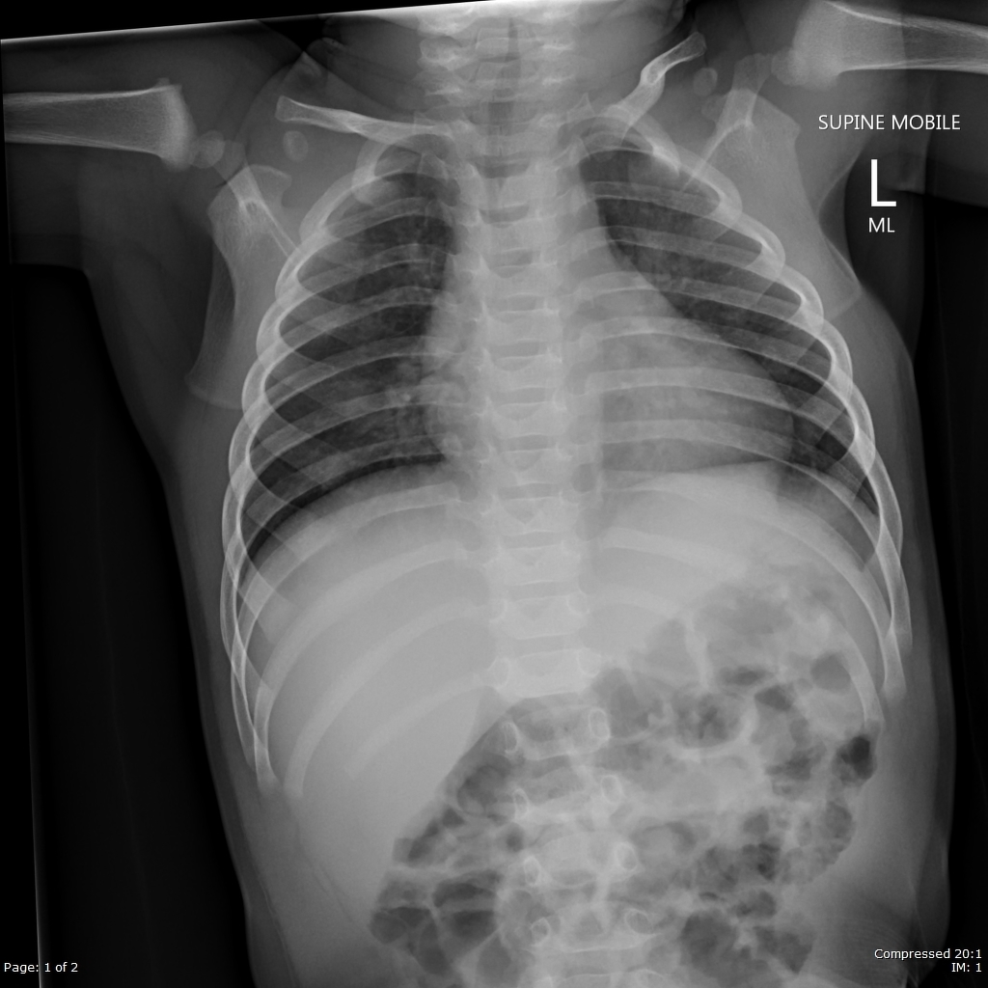

a. State the most relevant finding on the CXR (1 Mark)

_______________________________________________________________________________________

Steeple Sign indicating narrowed airway in croup

b. List three (3) potential complications during this intubation, and two (2) pre-emptive actions you will take to address each potential complication. (9 Marks)

Complication | Action 1 | Action 2

Complication | Action 1 | Action 2
Complete airway obstruction on induction/unable to pass tube through narrowed airway | Mark the neck for CICO situation/have needle cric airway equipment ready/prep team for likelihood of CICO | Have smaller ETT available than predicted – size 4 and 3.5 (vs 4.5 predicted)
Hypoxia | Adequate preoxygenation with 15L NRB or BVM or on NIV  Consider DSI with ketamine to maximise effective preox/bronchodilate | Apnoeic Oxygenation with nasal prongs at 15L+
Worsening Acidosis/Hypercapnia | BVM through the induction phase to prevent further acidosis and arrest  Have bicarbonate dose drawn (15mls 8.4%) in the event of acidotic arrest during intubation | Dose rocuronium high (1.4 mg/kg) to ensure minimum possible apnoeic time
Hypotension | Push dose pressors e.g adrenaline 1mcg/kg boluses or metaraminol | Preload with IVF bolus of 20mls/kg NaCl
Inadequate View – Grade III/IV or high anterior larynx | Use of a VL e.g CMAC | Brief team about BURP/ELM in event of poor view

After your 3 best attempts at oral endotracheal intubation you are unable to secure the airway. The child has saturations of 79% that are not responding to BVM ventilation. There is no fibre optic scope in your rural ED.

c. List the 4 most important steps, with brief details of each, in your Failed Intubation Plan (4 Marks)

_______________________________________________________________________________________
_______________________________________________________________________________________
_______________________________________________________________________________________
_______________________________________________________________________________________

-Declare CICO. Allocate roles and responsibilities.

-Place LMA Size 2 for ventilation while for surgical airway (LMA unlikely to be adequate for ongoing ventilation in croup but may temporise. Utilise nurse to deliver BVM which you address next steps)

-Needle cricothyoidotomy – aiming caudad 45 degrees, aspirate air, remove needle to leave catheter insitu

-Jet insufflation from wall O2 with device such as a Rapid O2/or with Y tubing/other appropriate device. Must allow full exhalation between inflations. Monitor sats for response. Monitor for air trapping.

Note – not appropriate to perform scalpel or percutaneous cricothyroidotomy as a FIRST approach in <8 years due to high rate of complications.
Candidates may state that they would perform this as a last resort if the needle cric is unsuccessful – this is appropriate given the lack of other available options and criticality of situation.

