Psychiatry SAQ_RDH Fellowship Program
Hot Topics in The Tropics

Restraint
Mental Health Triage
Involuntary detention
Mental health assessment/mental state exam
Organic brain syndrome
Panic –delineating organic disease e.g. PE vs hyperventilation
SADPERSONS scale
Bipolar
Medication Issues – long QTc, dystonic reactions, serotonin syndrome
Frequent presenters – administration question
Depression vs delirium vs dementia
Alcohol withdrawal
Anorexia/Starvation

Q1 (14 marks)

A previously well, 33 year old male builder has been brought in with several months of worsening, intermittently bizarre behaviour. He was found dishevelled and unclean, burying everyday objects in the garden this morning by a neighbour. He is in the waiting room and is pacing up and down and talking to himself. He has allowed the triage nurse to check his observations. She states that he was not engaging and would not speak to her or make eye contact

P 110
BP 140/97
RR 18
T 37.4
Sats 97%

a. List five (5) non-psychiatric diagnoses that you will consider in this man
__________________________________________________________________________________________
__________________________________________________________________________________________
__________________________________________________________________________________________
__________________________________________________________________________________________
__________________________________________________________________________________________

Stimulant or alcohol intoxication – (put these on one line – they are associated and high likelihood, but could conceivably only attract one mark for both as they are related – if on 2 lines will lose a mark – if on one line but get 2 marks they will still score both marks)
Endocrine diseases - Thyrotoxicosis
Frontal brain tumour
Early onset dementia - e.g. frontotemporal/Picks
Alcohol withdrawal state
Seizures e.g. temporal lobe epilepsy or post ictal state
Chronic infections such as neurosyphilis, prion diseases e.g. CJD (not acute infections!)
Steroid Use/Cushings
Porphyria
Less good ones that I would only use if cant think of others:
SLE
NMDA/AI receptor encephalitis
Severe B12 deficiency
Brain abscess (the duration of time here is too long for an acute meningoencephalitis but an abscess could I suppose do this)

Note: Avoid unlikely things like “acute” infections such as meningoencephalitis for something with a very long course

After discussion with the family you learn he seems to have no insight into his unusual behaviours. There is a strong family history of schizophrenia.

b. List four (4) features specific to schizophrenia, other than those mentioned thus far, that you will seek in your mental state examination of this man

__________________________________________________________________________________________
__________________________________________________________________________________________
__________________________________________________________________________________________
__________________________________________________________________________________________

Use DSM – 5 criteria for schizophrenia

Behaviour –Episodes of catatonic behaviour, or negative symptoms of social withdrawal, diminished emotions, responding to ext stimuli
Thought content – bizarre delusions
Speech/Thought Form – disorganised, tangential, frequent derailment or incoherence
Perception – Hallucinations often auditory – persecutory/paranoid/running commentary often, sometimes responding to external stimuli
Level of functioning in one or more major areas, such as work, interpersonal relations, or self-care, is markedly below the level achieved prior to the onset

Cognition – intact but can be hard to assess when the patient is unwell
Mood and Affect – pure schizophrenia doesn’t have a derpressed mood component – if it does is known as schizoaffective

Things already commented on in the stem so not allowed:
Insight – STEM
Appearance – nil specific but here is dishevelled and unkempt
Behaviour – grossly disorganised

He is attempting to leave the department and you believe he may need to be sectioned.

c. List the four (4) criteria he needs to meet to allow him to be legally sectioned (4 marks)

__________________________________________________________________________________________
__________________________________________________________________________________________
__________________________________________________________________________________________
__________________________________________________________________________________________

All 3 of the following
Have a mental illness
Need Rx
Do not gave capacity

PLUS
Danger to self and/or others

Q2 (11 marks)

A 23 year old female with a history of severe anxiety has presented to ED with suicidal thoughts in the setting of a situational crisis. The mental health team are busy and have asked that you make a preliminary assessment of her suicide risk until they can assess the patient fully.

a. List six (6) factors that will help you to make an assessment of her psychiatric risk level and guide the need for admission to hospital (6 marks)
__________________________________________________________________________________________
__________________________________________________________________________________________
__________________________________________________________________________________________
__________________________________________________________________________________________
__________________________________________________________________________________________
__________________________________________________________________________________________
__________________________________________________________________________________________

Modified SADPERSONS scale
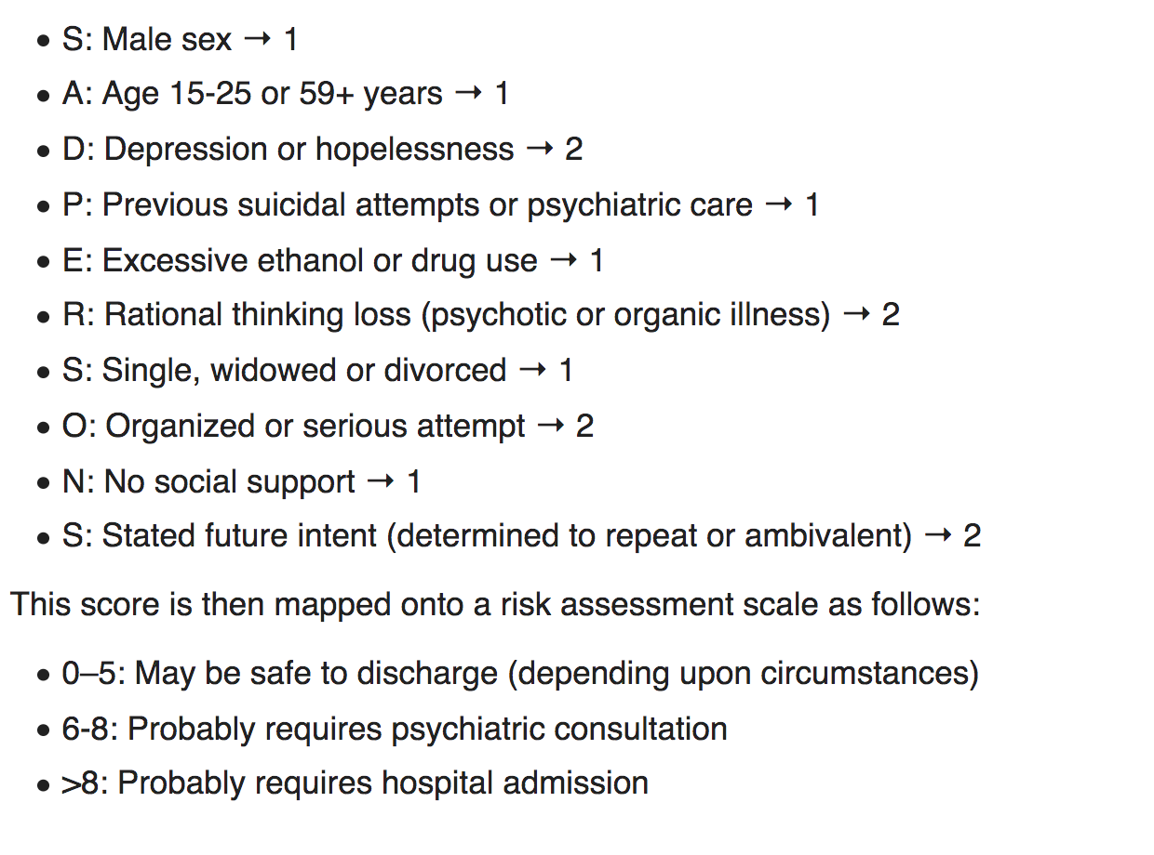
2 hours later patient is tearful and states that she wishes to leave because she needs to collect her child from daycare in another 2 hrs. You do not feel that she meets the criteria to be detained involuntarily under the mental health act.

c. List five (5) steps that you could take in this situation to minimise risk to the patient

__________________________________________________________________________________________
__________________________________________________________________________________________
__________________________________________________________________________________________
__________________________________________________________________________________________
__________________________________________________________________________________________

Offer her comfort measures – private room, tea,
Suggest/offer any of the following
- Calling a friend or someone that can provide support
- Calling social work to assist with arrangement for her child
Expedite an abbreviated assessment with the mental health team
Offer a phone assessment/follow up – or for her to return to ED once she has collected her child
Get permission to refer to GP or local outpatient service
Provide information about local resources for anxiety and depression
Offer usual medication if takes for anxiety

Q3 (11 marks)

A 78 year old woman has been brought in by her family. She has been increasingly slow and withdrawn for the last 12 months with several emotional outbursts over the last 2 months. She is staying in bed for a lot of the day and no longer participates in her previous social activities. The family took her to the GP today who referred her to ED with possible delirium.

She has a history of hyperlipidaemia only and takes a statin but no other medications

Observations
P 52
BP 150/90
T 36.5
RR 14
Sats 96% RA

BSL 4.1

a. List five (5) non-psychiatric differential diagnoses in this woman (5 marks)
__________________________________________________________________________________________
__________________________________________________________________________________________
__________________________________________________________________________________________
__________________________________________________________________________________________
__________________________________________________________________________________________

Hypothyroidism
Hypercalcaemia secondary to any reasonable cause
Frontal brain tumour
Dementia
MND
Parkinsons
Occult cerebrovascular disease
Renal failure –uraemia can precipitate these Sx

She remains in the short stay area of ED for several hours while some investigations are performed
At 10pm the intern tells you that she has become very agitated and is trying to climb out of bed.

c. List four (4) features that in general suggest a delirium rather than a depression (4 marks)

__________________________________________________________________________________________
__________________________________________________________________________________________
__________________________________________________________________________________________
__________________________________________________________________________________________

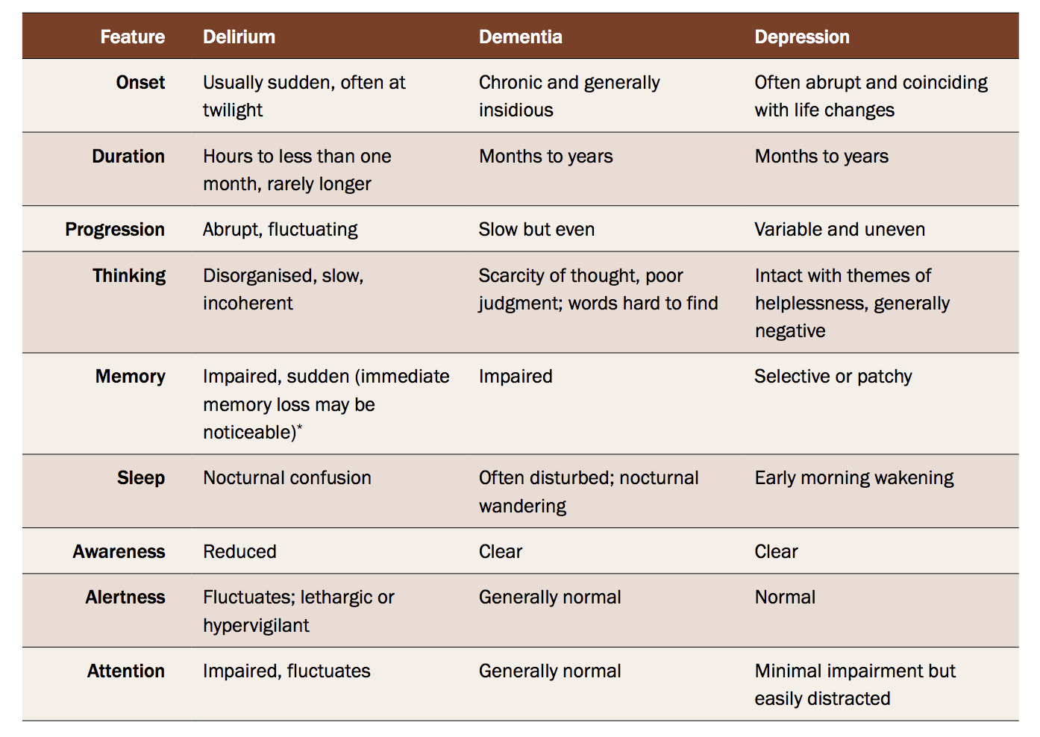

c. List the two (2) MOST appropriate pharmacological agents (with doses) that you could utilise as single agents for short term management of her agitation (2 marks)

__________________________________________________________________________________________
__________________________________________________________________________________________

Quetiapine
Risperidone
Olanzapine

Benzos are less perfect as they can cause sedation, aspiration, falls – only short acting and small doses appropriate
Haloperidol – less appropriate due to SE profile, increased risk of death

Q4 (11 marks)
A 34 year old man with a history of psychosis recently started on medication by the GP. He drinks harmful amounts of alcohol and is homeless. He has evidence of poor self care. He currently has painful spasms of his neck, eye deviation and grimacing. He is unable to give any history due to difficulty speaking but is indicating that he feels short of breath

P 120
BP 140/98
Sats 96 RA
Temp 37.1
RR 22

a. List three (3) medications that could be used for definitive management of his condition (3 marks)
__________________________________________________________________________________________
__________________________________________________________________________________________
__________________________________________________________________________________________

Diphenhydramine
Benztropine
Benzodiazepine
(Tetanus Ig)

b. List three (3) differentials for his presentation (3 marks)

__________________________________________________________________________________________
__________________________________________________________________________________________
__________________________________________________________________________________________

Dystonic reaction
Tetanus
Focal Seizures
?NMS
?SS

After treatment he has an ECG, which is shown below

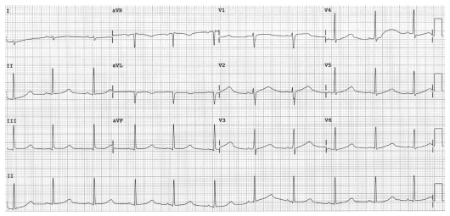

b. List five ( 5) potential causes for this ECG (5 marks)

__________________________________________________________________________________________
__________________________________________________________________________________________
__________________________________________________________________________________________
__________________________________________________________________________________________
__________________________________________________________________________________________

Drugs – Antipsychotics (plus others as below)
Electrolytes – HypoCa/Mg/K
Congenital
Ischaemia

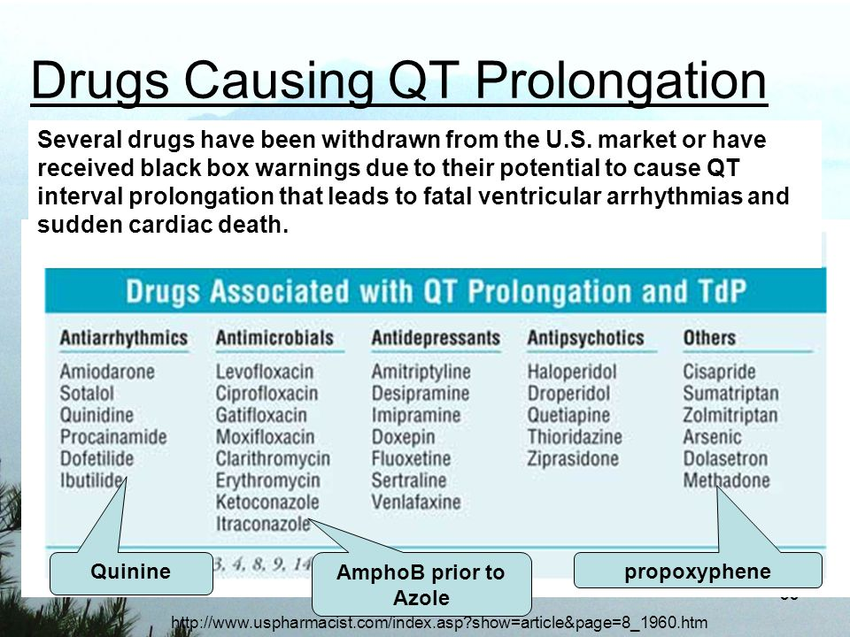

Q5 (15 marks)

A 15 year old girl presents after not eating for 10 days, she states that she is trying to starve herself to death because someone has sexually assaulted her. She is tearful and withdrawn and appears thin and dehydrated. Her father is a single parent and she has a younger sibling. Her father is en route to the hospital. She won’t disclose who assaulted her. The sexual assault team have been called

The blood tests and observations show the following

Hb 107 P 130
Plt 156 BP 90/60
WCC 12 Sats 97% RA
Cr 100 RR 22
Ur 8.9 T 36.1

CCa 2.23
PO4 0.34
Mg 0.4
K 2.1

a. List the immediate management of her nutritional status in ED (5 marks)
__________________________________________________________________________________________
__________________________________________________________________________________________
__________________________________________________________________________________________
__________________________________________________________________________________________
__________________________________________________________________________________________

Involvement of a dietician as risk of refeeding syndrome
Do not feed immediately – carbohydrate can precipitate lower phos/K and precipitate arrhythmias
Hydration, consider via IV or NG
Correct PO4 – will need IV 10mmol over 4-12 hrs on a monitor
Correct KCl –Oral 2 tabs bd and IV 10mmol at a time
Correct Mg- 10 mmol over 1-2 hrs
Recheck all electrolytes 4 hrly initially
Admit to med ward

b. List the ten other (10) issues that will need to be addressed in this child by the ED and sexual assault team (10 marks)

__________________________________________________________________________________________
__________________________________________________________________________________________
__________________________________________________________________________________________
__________________________________________________________________________________________
__________________________________________________________________________________________
__________________________________________________________________________________________
__________________________________________________________________________________________
__________________________________________________________________________________________
__________________________________________________________________________________________
__________________________________________________________________________________________

Determine if there are any immediate life threats/serious injuries that need to be treated
Determine if she is pregnant
Determine the need for post coital contraception
Determine the need for PEP for HIV/immunisation for Hep B
Screen for STDs
Determine the risk posed by immediate family members to her and her sibling - ??need to involve FACS
Adolescent Mental Health Assessment +/- admission – assess suicide risk
Ensure chain of evidence – brown bag all clothes, encourage her not to shower till seen by Sexual Assualt team
Involvement of paediatrics and mental health including admission to hospital
Contact police to report assault of a minor (mandatory reporting)

Q6 (marks)
A 17 year old previously well male has been sent in by his GP after his parents found him walking around naked in the garden. He was seen behaving normally 2 days ago. They returned from a weekend away to find the house in disarray. He appears confused. They report that he has been more withdrawn lately but has no history of mental illness.

P 110
BP 135/90
Sat 99% RA
RR 20
T 37.5

The GP is concerned that he has psychosis and has referred him to the mental health team.

a. In the table below list the five (5) MOST LIKELY non psychiatric differentials with 2 examination findings that you will seek for each (15 marks)

Diagnosis | Examination Findings

Stimulant toxicity – large pupils, agitation, overactivity,
Serotonin syndrome –Anything from hunter criteria
Anticholinergic toxicity – retention, large pupils,
Temporal lobe epilepsy/post ictal – bitten tongue
Head Injury – external evidence, neuro defecits, pupils, fundi,
Encephalitis - particularly limbic encephalitis – clouding of consciousness
UTI or other sepsis – more likely in elderly
Electrolytes – low Na

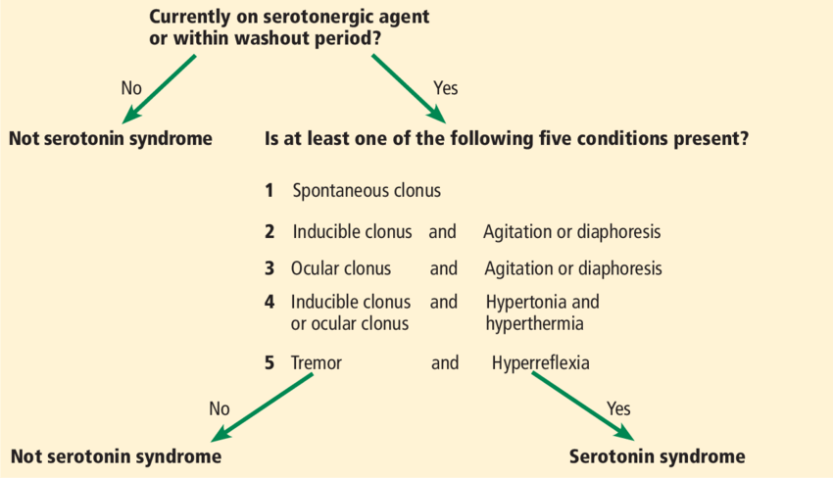

Q7 (14 marks)
A 25 year old male bodybuilder has been brought into ED after a methamphetamine binge by his girlfriend. He has become verbally aggressive and is threatening staff with violence. You have been unsuccessful at verbal de-escalation and he has refused to take any oral benzodiazepines. He is pacing in the corridor and refuses to sit down and talk. The decision has been make to phycially and then chemically restrain the patient.

a. List six (6) preparations you will make before physically and chemically restraining this patient (6 marks)
__________________________________________________________________________________________
__________________________________________________________________________________________
__________________________________________________________________________________________
__________________________________________________________________________________________
__________________________________________________________________________________________
__________________________________________________________________________________________

Explain to the patient what will happen
Call code black or similar - Security enough for 5 point restraint
Appropriate area with monitoring/O2/airways equipement
PPE for staff
Remove stethoscope/jewellery/other staff and patients
Briefing, code word, positioning etc
Drugs drawn up – midaz 10mg IM/droperidol 10mg IM/olanz

b. List 5 measures that can be utilised to prevent patient harm during restraint (5 marks)

__________________________________________________________________________________________
__________________________________________________________________________________________
__________________________________________________________________________________________
__________________________________________________________________________________________
__________________________________________________________________________________________

Supine positioning to sedate then in recovery position, never prone
No pressure on neck
Non restraint of torso
Don’t restrain hands behind back or hobble (arms to legs)
Monitoring in a safe area e.g. resus
1-1 nursing
Remove physical restrains as soon as chemically restrained
Adequate fluids
Pressure care

You are also in the planning stages of designing a new department that will open in 2 years from now.

c. List three (3) features you will incorporate into the department that will ensure staff and patient safety from violent patients

__________________________________________________________________________________________
__________________________________________________________________________________________
__________________________________________________________________________________________

Staff relaxation areas removed from patient waiting / treatment areas
Location of seclusion room(s) away from high traffic areas
Provision of a quiet area for disturbed patients to wait
Waiting areas of department not visible from the street
-passing rival gang members or friends may recognise an assailant and initiate an attack
Control of ED access, metal detectors, closed circuit or video surveillance, duress alarms and specifically Designed secure examination rooms should be considered in ED security

Q8 (12 marks)

A 130 kg 26 year old female presents to ED claiming to have taken 100 panadol tablets 3 hrs ago. She has a history of borderline personality disorder and has presented to ED 15 times in the last 6 months, she has been discharged each time. She has been seen by the mental health team who are happy for her to be discharged and followed up with her case worker in the community. Her panadol level is 0 at 2 hrs post ingestion.

She is demanding a script for oxycodone for her chronic back pain, which she tells you she takes on a PRN basis when the pain is bad. She is not taking any other medications. She has no physical abnormalities on examination and has had full investigation of her pain with a CT, MRI and bloods in the last month.

a. List the discharge advice you will provide to the patient (4 marks)

__________________________________________________________________________________________
__________________________________________________________________________________________
__________________________________________________________________________________________
__________________________________________________________________________________________

Simple regular analgesia with panadol and NSAID
Follow up with GP and mental health team as outpatient
No serious conditions found from toxicological or back pain perspective
Advise weight loss and exercise
Oxycodone side effects and why best to avoid – constipation, drowsiness etc
Crisis line number

b. List five (5) factors associated with frequent attending to ED (5 marks)

__________________________________________________________________________________________
__________________________________________________________________________________________
__________________________________________________________________________________________
__________________________________________________________________________________________
__________________________________________________________________________________________

•male gender
•older age
•attendance outside daytime hours
•substance abuse
•psychosocial problems
•intellectual disability
•somatic delusions
•chronic medical problems
•used multiple heath services regularly

You decide to write a patient protocol for the patient given her frequent attendances and disruptive behaviour.

c. Outline three (3) recommendations you will make in the patient protocol for this patient (3 marks)

__________________________________________________________________________________________
__________________________________________________________________________________________
__________________________________________________________________________________________
__________________________________________________________________________________________

Senior review – reg or consultant at all times
Assess per triage category/complaint
Minimise unnecessary investigations for chronic complaints
Not to be prescribed opiates from ED unless acute demonstrable illness – simple analgesia only

Q9 (marks)

A 31 year old man has presented to ED with SOB. He was started on clozapine for resistant chronic psychosis 4 weeks ago.
He doesn’t appear to have any features of acute psychosis currently

P 120
BP 90/70
Sats 99% RA
RR 24
Temp 38.8

He was due to see his GP for blood tests yesterday but missed his appointment because he was feeling unwell. ECG shown

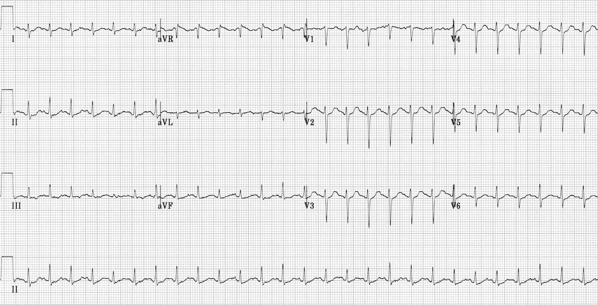

a. List the 3 MOST likely diagnoses for this patient (3 marks)

__________________________________________________________________________________________
__________________________________________________________________________________________
__________________________________________________________________________________________

Agranulocytosis with neutropenic related infection
Myocarditis
Chest infection

b. List the most important pharmacological agents the you will administer whilst waiting for investigation results (1 mark)
__________________________________________________________________________________________

c. List the 5 MOST important investigations you will order with reasoning

__________________________________________________________________________________________
__________________________________________________________________________________________
__________________________________________________________________________________________
__________________________________________________________________________________________
__________________________________________________________________________________________

WCC/Neuts ?agranulocytosis
Blood culture ?sepsis
Echo ?myocarditis – clarify EF and risk of heart failure
Trop ?myocarditis
CXR

