Psychiatry Fellowship Teaching Notes

Mental Health= more medical illness and injury, shorter life span by 8-30 yrs
50-90% chronic medical problems
meningitis/sepsis/tox/NMS/hepaticencephalopathy/withdrawal/thyroid/trauma/metabolic derangement
First presentation mental health = diagnosis of exclusion to rule out organic illness first
No consensus on what constitutes medical clearance or medically stable for psych admit
Ensure no weapons
Historical Features suggesting medical cause for Psych presentation
- No previous psychiatric history
- Recently hospitalized or with symptoms suggestive of possible infections
- Recent medication changes
- Sudden changes in behavior
- Visual hallucinations
- Extremes of life; age >40 y or <12 y
- New-onset seizure
- Recent memory loss
- History of substance abuse

Physical Examination Features Suggestive of Organic Causes of Psychiatric Complaints
- Abnormal vital signs
- Fluctuating level of consciousness/alertness (e.g., clouded sensorium)
- Significantly decreased level of consciousness (Glasgow Coma Scale score <8)
- Focal neurologic findings (e.g., new-onset seizures, inability to walk unassisted)
- Ophthalmologic abnormalities (e.g., rotary nystagmus)
- Evidence of trauma (e.g., raccoon eyes, Battle’s sign, septal hematoma, abrasions, lacerations)
- Abnormal dermatologic manifestations (e.g., rashes, purpura, jaundice, uremic frost, cool, mottled extremities)
- Abnormal mental examination or Quick Confusion Scale
- Presence of visual hallucinations

Interview Techniques in the ED
Safety
- Know where the exits are before you talk to the patient; stand close to exit
- Leave enough distance to avoid being physically hurt
- Wear a badge clip that cannot be used to choke you
Cooperation/rapport
- Always introduce yourself clearly
- Establish eye contact; smile if possible
- Reuse terms the patient uses to describe their condition before asking for clarification; this makes the patient feel heard
- Start with open-ended questions because they are best to establish therapeutic rapport
- Transition to close-ended questions if open-ended questions are not productive
- Last resort: Yes or no and multiple-choice questions

Violent Patients
- Verbal de-escalation
- Offer meds
- Explanation
- Listen
- Show of force
- 5 point restraint
  - Never prone
  - Ensure schedule completed
- Chemical sedation
  - Elevate head to stop aspiration
  - Monitoring
  - 1-1 nursing
  - Skin/toileting/fluids etc
  - Sedation scales
Capacity
A person has capacity to give informed consent to treatment or medical treatment if they:
- understand the information that is given to them about the treatment
- can remember the information relevant to the decision
- can use or weigh the information relevant to the decision
- can communicate the decision.
Involuntary Admission
- Has a mental illness
- No capacity
- Risk to self (physical/psychological/reputational
- Risk to others
- Cant be treated as an OP
- Least Restrictive means
Capacity vs Competency
Capacity - The ability to make a decision about a specific health matter at a discrete point in time. The concept includes the ability to understand risks and benefits of the suggested intervention, medication, or procedure; the repercussions of declining it; and alternative choices.
Competency - Legal term decided by court and extends to financial, health, and personal matters. It is not a dynamic concept like capacity. Absence of competence usually implies the presence of a legal guardian, either an individual or a court-appointed entity. The concept is not to be confused with power of attorney

Acute Agitation
Safety – verbal deesc – show of concern – treat medical problems – restraints used sparingly – medication – 2nd gen antipsychotics
Verbal Deescalation
- Respect personal space
- Do not be provocative
- Establish verbal contact
- Be concise
- Identify wants and feelings
- Listen closely to what the patient is saying
- Agree or agree to disagree
- Lay down the law and set clear limits
- Offer choices and optimism
- Debrief the patient and staff

Sedation assessment tool
Score | Responsiveness | Speech
+3 | Combative, violent, out of control | Continual loud outbursts
+2 | Very anxious and agitated | Loud outbursts
+1 | Anxious/restless | Normal/talkative
0 | Awake and calm/cooperative | Normal
–1 | Asleep but rouses if name called | Slurring or prominent slowing
–2 | Responds to physical stimulation | Few recognizable words
–3 | No response to stimulation | Nil

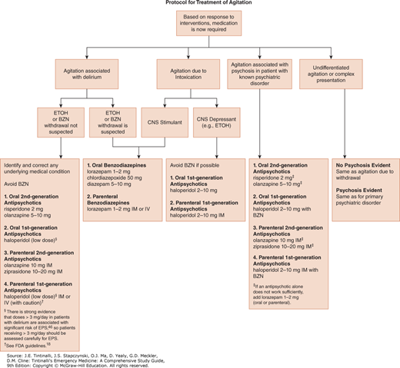
Ketamine – hypersalivation, hypertension/tachycardia, frequent redosing, ??worse psychosis (unproven)
Haloperidol – QTc prolongation, motor side effects, don’t use
Olanzapine – 10mg IM is as sedating as 5mg midazolam, less somnolence, increased airway issues if given IV (don’t do)

Elderly Mental Health
Dementia vs Delirium vs Depression
Depression = increased risk of dementia
Features of Delirium, Dementia, and Psychiatric Disorder
Characteristic | Delirium | Dementia | Psychiatric Disorder
Onset | Over days | Insidious | Varies
Course over 24 h | Fluctuating | Stable | Varies
Consciousness | Reduced or hyperalert | Alert | Alert or distracted
Attention | Disordered | Normal | May be disordered
Cognition | Disordered | Impaired | Rarely impaired
Orientation | Impaired | Often impaired | May be impaired
Hallucinations | Visual and/or auditory | Often absent | May be present
Delusions | Transient, poorly organized | Usually absent | Sustained
Movements | Asterixis, tremor may be present | Often absent | Varies

Medication side effects more frequent – EPSE/sedation/falls
Dose lower
Check interactions/ECG for QTc
Delirium
Hypoactive/hyperactive/mixed
Predictor of 6 month mortality, increased LOS, hospital complications, need for NH on discharge, lasting cognitive deficits
Old people – lower baseline temp/altered pain responses/abdo exam/BB/wider pulse pressure/higher BP
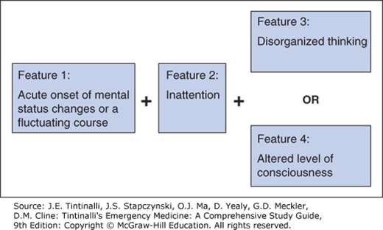

DELIRIUM: Mnemonic for Reversible Causes of Delirium
Drugs | Any new additions, increased dosages, or interactions  Consider over-the-counter drugs and alcohol  Consider high-risk drugs*
Electrolyte disturbances | Dehydration, sodium imbalance, thyroid abnormalities
Lack of drugs | Withdrawals from chronically used sedatives, including alcohol and sleeping pills  Poorly controlled pain (lack of analgesia)
Infection | Especially urinary and respiratory tract infections
Reduced sensory input | Poor vision, poor hearing
Intracranial | Infection, hemorrhage, stroke, tumor  Rare; consider only if new focal neurologic findings, suggestive history, or diagnostic evaluation otherwise negative
Urinary, fecal | Urinary retention: “cystocerebral syndrome”  Fecal impaction
Myocardial, pulmonary | Myocardial infarction, arrhythmia, exacerbation of heart failure, exacerbation of chronic obstructive pulmonary disease, hypoxia

Prevention – low stimulus, glasses and hearing aids, reorientation, avoid anticholinergics sedatives and opiates, family support, bathroom access, sleep, hydration, avoid IDC, nutrition

Mental Status Examination
Appearance, behavior, and attitude
Is dress appropriate?
Is motor behavior at rest appropriate?
Is the speech pattern normal?
Disorders of thought
Are the thoughts logical and realistic?
Are false beliefs or delusions present?
Are suicidal or homicidal thoughts present?
Disorders of perception
Are hallucinations present?
Mood and affect
What is the prevailing mood?
Is the emotional content appropriate for the setting?
Insight and judgment
Does the patient understand the circumstances surrounding the visit?
Sensorium and intelligence
Is the level of consciousness normal?
Is cognition or intellectual functioning impaired?

DSM diagnostic criteria
