OSCE Name: Examination

Candidate Information

Domains Tested
- Medical Expertise (50%)
- Communication (30%)
- Scholarship and Teaching (20%)

A 32 year old woman has presented with knee pain after an injury whilst playing netball. The medical student has asked if she can accompany you while you see the patient as she isn’t sure about assessing knees.

Tasks:
- Take a focussed history from the patient
- Teach the medical student how to examine the patient’s knee – you should do the examination and describe to the medical student what you are doing and why
- Interpret the XRay and explain the further management to the patient

Role Player Information

You are a 32 year old fit and healthy female. You have just tried to play your first game of netball in 3 years after having a baby and have injured your left knee.
You jumped to block a shot and landed awkwardly with a twisting motion, you then fell to the ground and your knee impacted the ground.
You have not been able to weightbear since and have had no treatment, ice, painkillers or anything else
You have anaphylaxis to aspirin so try not to take any painkillers of any sort

You cannot weightbear
Tender to bilateral joint line
Limited flexion to 30 degrees
Full extension
Any ligamentous testing is painful
Patella not sore
If the candidate tries to do McMurrays/grind tests you tell them it is too sore

PMH – anaphylaxis to aspirin – have an epipen (note never had other NSAIDS), # wrist as child

SH – Single parent of a 2 year old, work 3 days a week as a receptionist, mum lives nearby and can help

Non smoker
No etoh

If not covered you should ask

- What about work? Do you think I’ll be able to go
- Is it a bad injury?
- Will I need an operation?
- Can I take nurofen

Marking Scheme

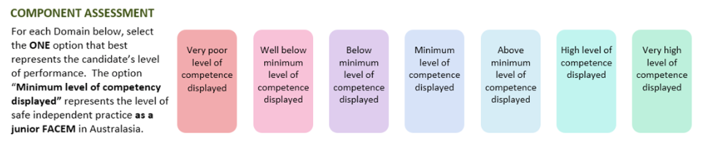

Medical Expertise

Communication

Scholarship/Teaching

DETAILED ASSESSMENT CRITERIA
Please use the following criteria to inform your ratings

Medical Expertise
- Adequate history taking including note of mechanism/weightbearing
- Not given NSAIDS as aspirin allergy
- Considers social setting – child/work etc
- Examination includes palp/active/passive/ligamentous tests/neurovasc status/joints adjacent briefly
- Recognises Segond # - need for further imaging with MRI and ortho follow up
- Explains risk of ACL and meniscal injuries
- Splinting with either RMO brace or zimmer
- Appropriate advice to ice, elevate, rest, crutches, Panadol +/- other (no nsaid)

Communication
- Clear instructions to patient, explains management
- Explains and demonstrates to student the appropriate examination technique

Scholarship and Teaching

- Clear explantation at a reasonable pace
- Checks understanding
- Recaps

