OSCE: Ventilate Me

Candidate Information

Domains Tested
- Medical Expertise
- Prioritisation and Decision Making
- Teamwork and Collaboration

This station is a SIMulation based OSCE. You are expected to be the team leader in this scenario and will direct 1 doctor and 1 nurse to manage the patient.

You are the on call Consultant for a rural hospital without an ICU. The nearest tertiary referral centre is 60 minutes by road. You have been called in from home by the nightshift registrar at 3am. He has been trouble ventilating a patient with asthma that he has just intubated urgently in the ED. The patient is a 23 year old man with brittle asthma who has been deteriorating over the past 3 days with wheeze, cough and reducing exercise tolerance.

The patient has been intubated with ketamine 200mg and rocuronium 150mg. There was a grade 1 view and the intubation was uncomplicated. There were immediate difficulties with ventilation however. The patient is an an oxylog ventilator

Observations

Sats 78%
RR 25
P 140
BP 80/60
T 37.9

Actor Information

Registrar
You are a PGY 5 Registrar who is 2 years into advanced training. The patient presented in extremis, was cyanosed and hypotensive. There was only yourself and 2 nurses in the ED with no support from anaesthetics or ICU available. You called the consultant in as soon as you had crash intubated the patient.

The patient is from interstate so you don’t know much about him other than he has “bad asthma”. He had an empty ventolin inhaler in his pocket.

He had 1x 5mg ventolin neb and 500mcg atrovent neb prior to intubation, but nothing since
He was easy to intubate with 200mg propofol and 150mg rocuronium.
Grade 1
Size 8.0 ETT
Bougie used

Immediately after intubation you put him on an oxylog with settings below:

SIMV
Vt 500
RR 25
PEEP 10
FIo2 1.0
PS 10

He has been hypoxic and has very poor chest compliance since – you are really worried but gave never ventilated an asthmatic so don’t know how to trouble shoot the problem. The vent has been alarming high pressures and you are stressed that he is going to get a PTX

You haven’t yet done a CXR or VBG yet

Nurse

You are an experienced ED nurse of 20yrs and can do all of the tasks that you are asked (if reasonably expected tasks for a senior nurse)

If the trainee gives you more than 2 tasks at a time – ask him which one you should do first

If the candidate doesn’t do a chest XR by the 5 min mark you should say
“should I call XRay, I have got the VBG here”
Hand the VBG to the candidate at that point (or earlier if asked for it specifically)

Examiner Information

The ventilated asthmatic patient has a combination of the following issues

- Hypoxia
– Compliance Low
-Needs more bronchodilators (via vent/IV salbutamol/?aminophylline/change to ketamine infusion or sedation )
- Hand Vent to test compliance – better candidates will want to feel the compliance themselves
- VQ Mismatch
- Pneumonia (appropriate abx)
- Breath Stacking
- Disconnect and squeeze
- Vent settings Low and Slow (RR 6-10, Vt low, PEEP 0-5, pH allowed 7.1)
- Secretions in ETT
- Suction cath down ETT
- Ventilator Dysynchrony
- Resedate with ketamine
- Paralyse with roc/sux
-

- Hypotension
- Secondary to chest sepsis, breath stacking, intubation drugs, dehydration from insensible losses
- Fluid bolus
- Management of breath stacking (see below) with disconnect and permissive vent strategy
- Exclude PTX
- Start inotropes NAd

The candidate should request the VBG result and CXR

VBG shows met and resp acisosis (severe)
CXR shows bilateral pneumonia (mycoplasma)

The candidate should mention the need to transfer the patient to a tertiary centre.

Props

VBG

pH 7.15
pCO2 70
HCO3 17
Lact 4.7

Hb 130
Na 134
K 3.1
Cl 98

Cr 123
Gluc 7.6

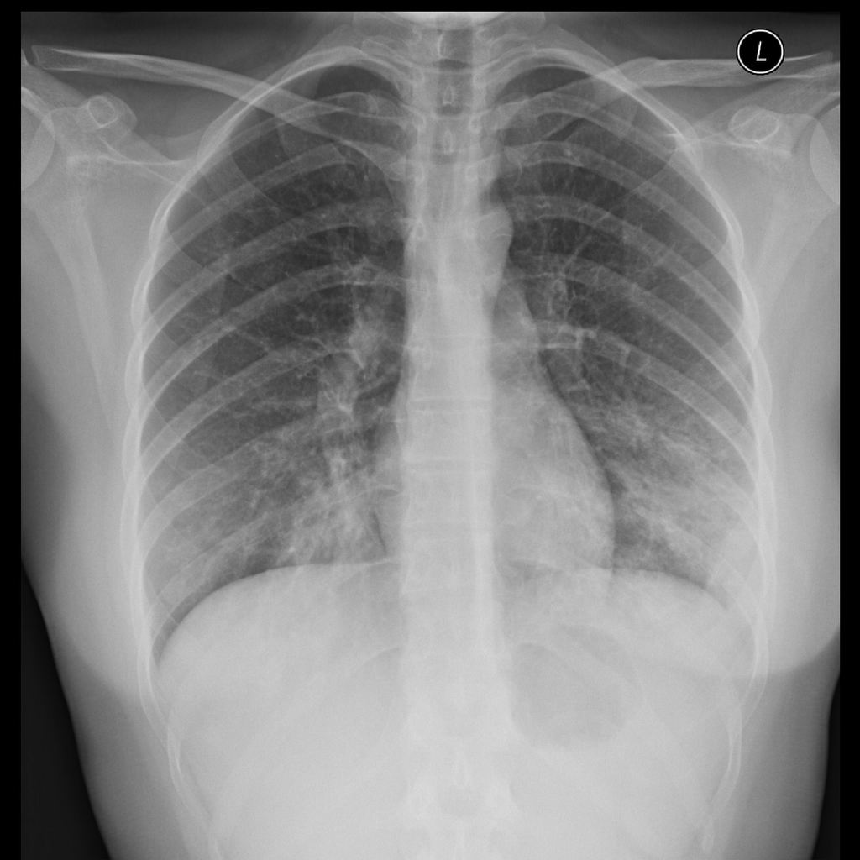

Marking Scheme

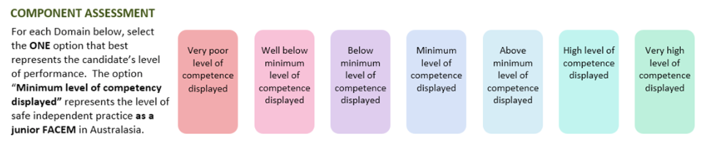

Medical Expertise
Communication
Prioritisation/Decision Making

DETAILED ASSESSMENT CRITERIA
Please use the following criteria to inform your ratings

Medical Expertise

- Hypoxia
– Compliance Low
-Needs more bronchodilators (via vent/IV salbutamol/?aminophylline/change to ketamine infusion or sedation)
- Hand Vent to test compliance – better candidates will want to feel the compliance themselves
- VQ Mismatch
- Pneumonia (appropriate abx)
- Breath Stacking
- Disconnect and squeeze
- Vent settings Low and Slow (RR 6-10, Vt low, PEEP 0-5, pH allowed 7.1)
- Secretions in ETT
- Suction cath down ETT
- Ventilator Dyssynchrony
- Resedate with ketamine
- Paralyse with roc/sux

- Hypotension
- Secondary to chest sepsis, breath stacking, intubation drugs, dehydration from insensible losses
- Fluid bolus
- Management of breath stacking (see below) with disconnect and permissive vent strategy
- Exclude PTX
- Start inotropes NAd

Correctly interprets VBG - severe resp and metabolic acidosis
Correctly interprets CXR – bilateral pneumonia, no PTX

Teamwork and Collaboration
Immediately assumes leadership
Clear, calm and concise instructions to team
Checks understanding/skillset
Closed loop feedback
Asks team for input
Early call to retrieval team with appropriate succinct information handling

Prioritisation and Decision Making
Outlines the order of immediate actions to the team – recognising that only 2 staff members = underresourced
Recognises that requires transfer but makes statement regarding optimisation whilst team are en route
Requests appropriate investigations – CXR and VBG

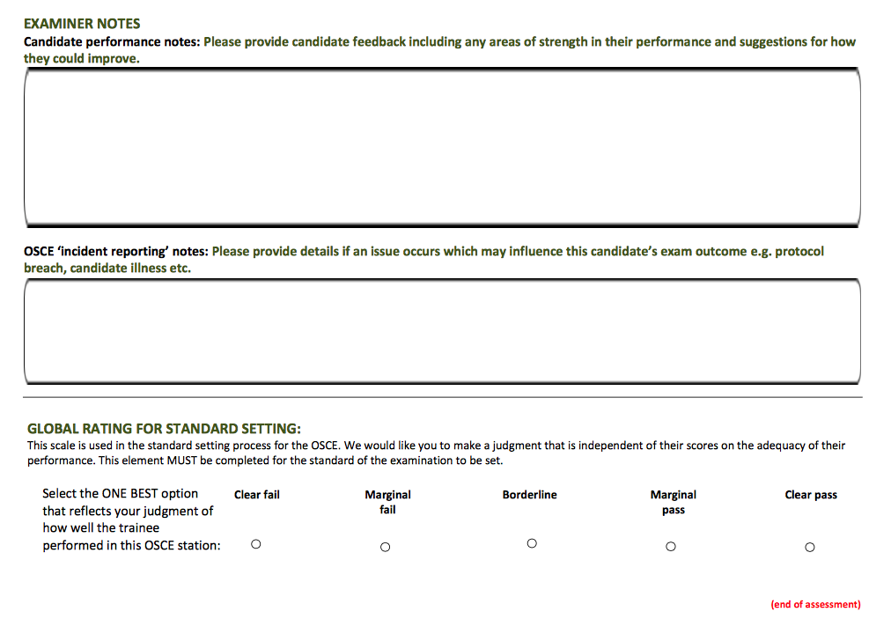

Notes
THE CRASHING ASTHMATIC - Mnemonics

Mash = assessment
Movement of chest
Arterial sats
Skin colour
Hypotension

Dopes = Ventilatory Problems
Dislodged ETT
Obstructed ETT
Patient factors (pneumonia/PTX/PE/chest wall compliance)
Equipment
Stacking

SHIT = Causes of Hypotension
Stacking
Hypovolamia
Induction agents
Tension PTX

