OSCE_Teach Procedure

Candidate Information
Domains Tested
Medical Expertise
Teaching and Scholarship

Clinical Stem
An intern is keen to suture a patient with a simple laceration on his back. The patient’s wound has been assessed by you as being a simple superficial injury that will require 4 vertical mattress sutures. The patient is fully consented.It has already been thoroughly irrigated with 500mls sterile saline, and the aseptic field set up.

This station utilises a TASK TRAINER

Tasks:
- Give the intern an appropriate pre-procedure briefing about the injury and the planned procedure
- Place the first 2 sutures yourself as a demonstration
- Supervise the intern placing 2 sutures
- Answer any questions that the intern asks you

Role Player Information
You are a new intern, only qualified for a month. You are very keen to learn some new suturing techniques. You feel comfortable placing simple interrupted sutures but have never tried any other techniques. You have heard of a vertical mattress suture but don’t know what it is used for or how to do it.

You would like to have a demonstration and then try yourself.

The candidate should explain to you the preparation needed for the procedure, and when this type of suture is useful

If they do not explain about “asepsis” with skin prep, sterile equipment, gloves drapes etc you should ask
“Is this a sterile procedure”

If they don’t explain the type of suture you should ask
“So is this a better suture for ALL wounds”

When you go to place your first suture you must do it incorrectly by starting far too close to the wound edge. The candidate should ideally correct your mistake and ask you to do it again.

After the sutures are placed ask the following questions

Examiner Information

Marking Scheme

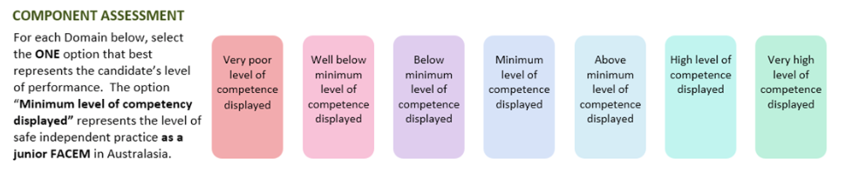

Medical Expertise

Communication

Professionalism

Scholarship/Teaching

Leadership/Management

Prioritisation/Decision Making

Health Advocacy

Teamwork/Collaboration

DETAILED ASSESSMENT CRITERIA
Please use the following criteria to inform your ratings

Medical Expertise

Communication

Professionalism

Scholarship and Teaching

Leadership and Management

Prioritisation and Decision Making

Health Advocacy

Teamwork and Collaboration

