OSCE: Shoulder Exam
Time: Single Station, 3m reading, 7m station
Author:Rebecca Day
Medical Expertise
Communication

Clinical Scenario Stem
A 42 year old man (Mr Jones) presents to your minors department having been referred by his GP. He has had aches from his right shoulder for a number of weeks, but the pain become acutely worse yesterday after swimming.

Instructions

Candidate

Please EXAMINE this man’s right shoulder.

You will be asked the following questions at the 6 minute mark
What is your diagnosis?

What is your management plan?

Patient - Actor
You have supraspinatus tendonitis/?tear.

Pain on palpation of greater tuberosity
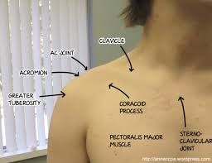

You have a painful arc
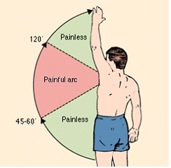
and positive supraspinatus test/Jobs Test (see pic
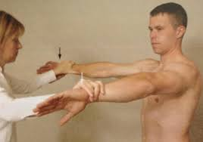

Examiner
You are to watch the examination without interruption. At the 6 min mark you should ask the candidate to explain their diagnosis, investigation and management

Assessment Criteria

DOMAIN | Performs poorly, nowhere near the level of a new FACEM | Performs  significantly below the level of a new FACEM | Performs below the level of a new FACEM | Borderline at the level of a new FACEM | Performs at the level of  a new FACEM | Performs very well, above the level expected of a new FACEM | Performs exceptionally and far exceeds the level of a new FACEM
Communication

Medical Expertise

Professionalism

Prioritisation

Detailed Assessment Criteria

Communication
- Introduces

Medical Expertise

OBSERVATION | POSITIVES
Introduces self to patient and confirms patients details
Confirms side of injury
Asks if patient is in pain
Briefly describes what they intend to do during examination – look/feel/move
Has both shoulders exposed for examination.
Patient seated
Inspects for swelling / erythema/scars/muscle wasting inspecting side, front and back
Palpates : SC joint / clavicle / AC joint / subacromial space / bicipital groove / lesser tuberosity / greater tuberosity / scapula for tenderness / crepitus / swellings and their nature | Painful over greater tuberosity
Assess movements active and passive: flexion / extension / abduction noting scapulothoracic component / adduction / rotation with elbow flexed to 90 degrees | Pain on initiation of abduction
Assess rotation IR in extension (placing arm to level T7 normal) and ER in abduction (placing hand on back of head and down to opposite scapula)
Tests muscle strength (MRC grading):
Flexion
Extension
Abduction – deltoid and supraspinatus
Adduction
ER with elbow flexed – infraspinatus and teres minor
IR with elbow flexed - subscapularis
Supraspinatus test = Jobs test. Flex shoulder to 90 degrees adduct to 20 degrees and thumb down. | +ve supraspinatus test/Jobs
Subscapularis test = lift up test. Place hand into small of back IR in shoulder extension. Resist movement and lift hand off.
Evaluates painful arc / drop arm test for rotator cuff tear | Painful arc
Speeds test – full arm supination, shoulder flexion and resist. Pain = labral / biceps tendon pathology.
Crank test for labral tear – abduct and IR shoulder, axial pressure and move through ER/IR. Pain = labral tear
Apprehension test. Abduct and ER shoulder. Patients face gives clue to possible anterior instability.
Diagnosis = SUPRASPINATUS LESION
Analgaesia / XRAY for calcification / USS ?tear/ poss steroid injection / analgesia/physio and follow up

