OSCE: SCBD_

Candidate Information

This station is a Structured Case Based Discussion. You will be engaging in conversation with another FACEM regarding a case that the other FACEM saw yesterday. He is keen for your input into

Domains Tested
- Medical Expertise
- Prioritisation and Decision Making

Role Player Information

Examiner Information

Marking Scheme

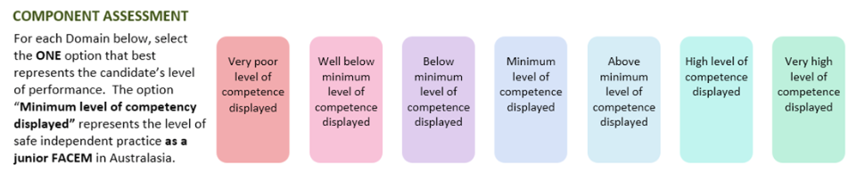

Medical Expertise

Communication

Professionalism

Scholarship/Teaching

Leadership/Management

Prioritisation/Decision Making

Health Advocacy

Teamwork/Collaboration

DETAILED ASSESSMENT CRITERIA
Please use the following criteria to inform your ratings

Medical Expertise

Communication

Professionalism

Scholarship and Teaching

Leadership and Management

Prioritisation and Decision Making

Health Advocacy

Teamwork and Collaboration

