OSCE: Paed Arrest

Candidate Information

Domains Tested
- Prioritisation and Decision Making (30%)
- Medical Expertise (40%)
- Teamwork and Collaboration (30%)

This station is a SIMulation based OSCE. You are expected to be the team leader in this scenario and will direct 1 doctor and 1 nurse to manage the patient.

You have been called in from home to assist with a paediatric cardiac arrest in a rural setting. The hospital is 1 hr by road from the nearest tertiary centre.
A 5 year old boy has had an unexplained cardiac arrest. A PCA has called you because the only nurse and doctor in the department are resuscitating the child. You arrive 10 minutes later. The doctor will give you a handover when you arrive.

Tasks:
Receive handover and establish what has happened prior to your arrival
Outline the assessment and management priorities to the team
Interpret any information that you are given during the scenario

Role Player Information

Doctor
You are a junior registrar at a rural hospital where only 1 nurse and 1 doctor are on shift overnight. A five year old child (est weight 20kg) was BIB his mother 30 minutes ago. His mother drove him from 2 hrs away, they live in a rural community. He was obtunded and shocked on arrival and soon after had a PEA cardiac arrest.

Arrival observations were

P 50
BP unrecordable
Sats 90% RA
RR 40
Temp 34.2

You started CPR, intubated and gave him 2 fluid boluses of 20mls/kg via an IO. He then got ROSC after the second bolus. No shocks delivered
He looks very dehydrated. You have subsequently got IV access (VBG sent but results only available if candidate asks for them)
He currently has a 5.5 ETT in situ and is on SIMV (Vt 100mls/PEEP 8/RR 26/PS 10)
The mother is unable to explain why he is unwell and says “he just got worse quickly today, he was vomiting for 3 days”. She has disappeared into the car park

You haven’t seen the VBG yet.
You haven’t done a glucose yet
The radiographer is on the way in to do a CXR
Chest is clear but haven’t yet had opportunity to fully examine the child.

Current observations
P 70
BP 50/30
Sats 99% LMA 100% FiO2
RR 40
Temp 34.7

If asked to examine the child
- Chest clear/HS dual/abdo slightly distended/few bruises to shins/no evidence of facial trucal or limb injuries anteriorly
- ONLY examine the back of the child if specifically asked to do so, the candidate should direct you to specifically do this

Nurse
You are an experienced ED nurse of 20yrs and can do all of the tasks that you are asked (if reasonably expected tasks for a senior nurse)

If the trainee gives you more than 2 tasks at a time – ask him which one you should do first

When asked to give antibotics ask “do we need to do an LP first?”

Examiner Information

The candidate enters the room to find that the 5 year old child has ROSC. The team have an airway secured with an effective ETT and both IO and IV access. A VBG is currently being processed and will be handed to the patient 30 seconds after they arrive.

The candidate should receive handover and direct the team as to the current priorities.

Assessment
- BSL
- VBG ?acid base status/electrolytes/signs DKA/lactate/Hb
- CXR
- Physical exam with potential diagnoses/issues in mind
ETT position
Hydration indices
Peritonism
Head injury/Abdo injury
NAI
Sepsis (chest/skin/abdo)

- Advise NOT for LP as obtunded and unclear if been head trauma/raised ICP

Management
- Ongoing fluid replacement/access
- Sedation and paralysis
- Inotropes, initially peripherally, consider CVC
- Adjunts NG/IDC
- Consideration of parental information/SW/?need for police if NAI suspected
- Need for urgent retrieval to facilitate onwards ICU Mx/CT etc
- Communication with receiving centre

Better candidates will share their mental model with the team
Props

VBG

pH 7.13
pCO2 27
HCO3 12
Lact 6.7
Gluc 2.9

K 3.4
Na 131
Cl 91
Hb 159

Marking Scheme

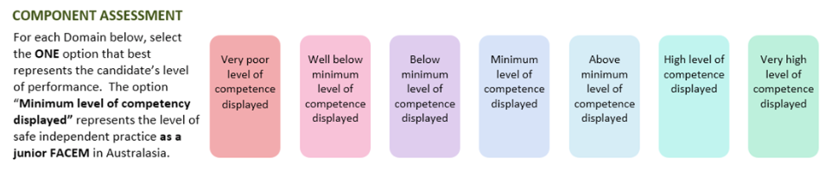

Medical Expertise

Teamwork and Collaboration

Prioritisation/Decision Making

DETAILED ASSESSMENT CRITERIA
Please use the following criteria to inform your ratings

Medical Expertise
Assessement

- Physical exam to rule out
- sepsis source
- trauma inc head injury and NAI
- abdominal catastrophe
- DKA
- dehydration
- ETT position

- VBG/sending of formal bloods including septic screen
- Identifies lactic HAGMA
- Borderline low K
- Low glucose

- CXR
- States need for (not available)

Management
- Identifies need for:
- Ongoing ventilation – ventilator parameters appropriate
- IV Fluids with 20mmol KCL per 1L
- Broach spectrum antibiotics to cover sepsis (
- Noradrenaline (or other appropriate inotrope)
- Ongoing sedation +/- paralysis
- Glucose 3mls 10%/kg = 60mls
- NG/IDC
- Avoidance of hyperpyrexia – acknowledges that low temp – opts not to actively rewarm
- Retrieval to tertiary centre for definitive imaging/ ICU level care

Teamwork and Collaboration
Actively listens to the handover without interruption
Explains plans/thought processes to the team with clarity
Gives team an opportunity to ask questions/clarify
Outlines key tasks and priorities succinctly

Prioritisation and Decision Making
Manages circulatory dysfunction/low glucose/early antibiotics as priority
Early identification of need for transfer via retrieval service to tertiary centre
Considers broader issues in an undifferentiated unwell child
- NAI/parental issues/resource scarcity
Doesn’t embark on any dangerous courses of action
- e.g. LP in obtunded child

