OSCE Name: Bite Me

Candidate Information

A 23 year old male has presented after being bitten by something whilst in the car park of a local national park. His friend placed a PIB and the man was brought to your tertiary ED by ambulance.
You are meeting him for the first time

Your tasks are the following:
- Perform a risk assessment of the patient including a focussed history and examination
- Explain to the patient what will happen next
- Answer any questions that the patient may have
A WBCT is by the bedside, you will be informed when it has been standing for 20mins
No other laboratory results will be available during this OSCE

Domains Tested
- Communication
- Medical Expertise
- Prioritisation and Decision Making

Role Player Information

23 Male, fit and well
PMH – appendicectomy and broken arm as a child, no meds, NKDA

You were in the car park of the national park and decided to go for a wee in the bushes, when you stepped into the long grass you felt something bite your leg. It hurt a lot and left 2 marks. You heard something moving in the bushes but did not see a snake.
Your friend is a trained first aider and he applied a bandage and made you lie still till the ambulance got there and put a drip in.

You feel nauseated and have a mild gradual onset headache.
No collapse
No bleeding from anywhere

Examiner Information

Marking Scheme

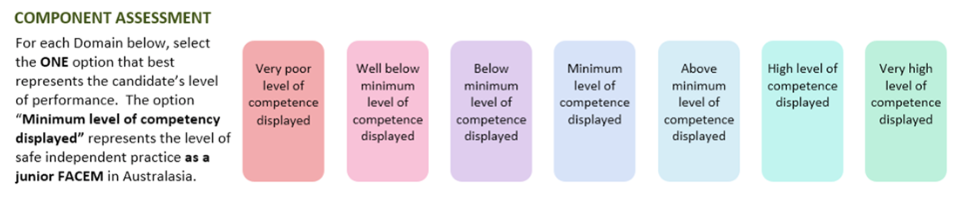

Medical Expertise

Communication

Professionalism

Scholarship/Teaching

Leadership/Management

Prioritisation/Decision Making

Health Advocacy

Teamwork/Collaboration

DETAILED ASSESSMENT CRITERIA
Please use the following criteria to inform your ratings

Medical Expertise

Communication

Professionalism

Scholarship and Teaching

Leadership and Management

Prioritisation and Decision Making

Health Advocacy

Teamwork and Collaboration

