OSCE: NAI Suspicion

Candidate Information

You are a FACEM on a paediatric emergency shift in an urban district hospital. The ED registrar is concerned about a fracture that they have discovered in a 6 year old boy.

The Xray is shown

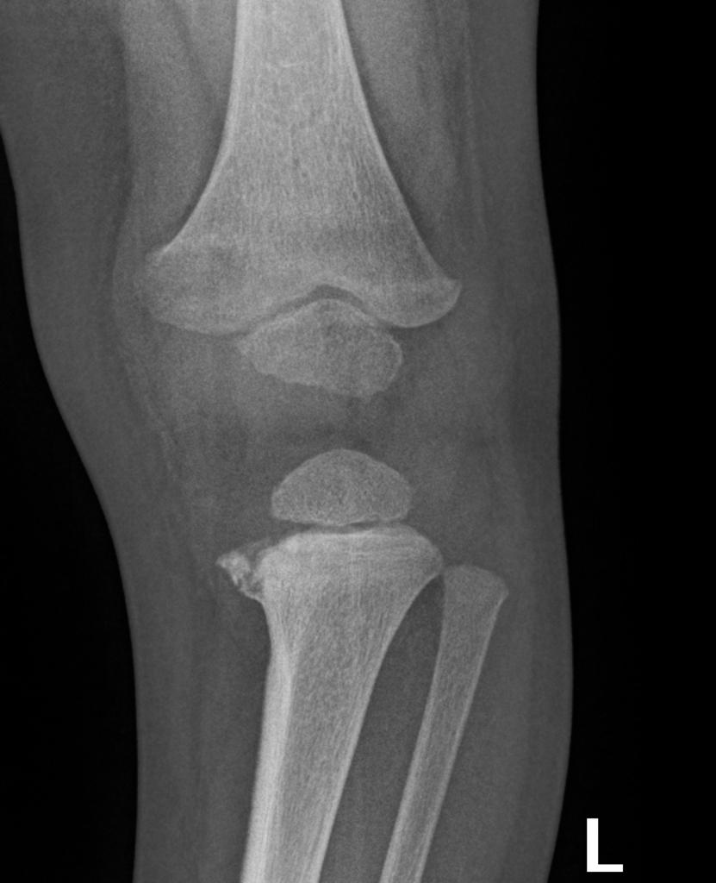

The parent of the child states that the child fell from a trampoline today and has refused to weight bear since. His story has changed a few times and he is guarded in his reponses. The child has never been to your hospital before and the family recently moved from interstate. No disclosed PMH/Meds/Allergies. Normal birth. Lives with Mum (Lara) who is on holiday in Bali and Dad (Kevin) who is currently unemployed. No disclosures of drug or alcohol abuse in the household. Detailed examination revealed a withdrawn child with 3 large bruises on the their back, a temporal haematoma and a swollen left knee. Observations, including GCS, are normal.
When the registrar raised concerns about the nature of the injuries, the father became verbally aggressive and swore at the registrar before stating that he wants to leave with the child before treatment is complete.

The child is well analgised, is safe with his grandma and is being reviewed by the paediatric and orthopaedic registrars currently in another area.

Assume there is a security staff member at the door of the room

Your task:
-Talk to the father and explain the situation and necessary next actions
-Answer any questions that the father may have

Domains Tested
- Communication (50%)
- Medical Expertise (30%)
- Prioritisation and Decision Making (20%)

Role Player Information

When the FACEM enters the room you should say
“ahhhh, here we go. I suppose youre the fucking head honcho are you”

If he introduces himself and tries to shake hands you refuse to shake and say
“There’s no way Im shaking your hand, don’t know where you’ve been”

You are a 26 year old unemployed father called Kevin. Your only child is Luke and he is 4 years old
You took your child into Emergency because he couldn’t walk. You have told the staff that he fell from a trampoline today, when in fact you got drunk last night and assaulted him physically because he was being naughty. You do not disclose this fact to the ED consultant under any circumstance and get very angry if there is any suggestion that you harmed your child. Your wife, Lara, is in Bali with her friends for another 3 days. She has never harmed Luke and has no idea that you would do this.

You have just moved from interstate (QLD) – this way because you owed someone money for drugs but this is not to be disclosed

You are now panicking that you have been found out and want to leave before anyone involves the “pigs”. You are a particularly unpleasant character with a personality disorder. You will tell lies and do anything not to be “found out”

You raise your voice but do not directly threaten violence.

If asked you state no to most medical questions
- born on time – if asked “was he a term baby”, state….”what does that even mean”?
- No trips to hospital ever
- No illnesses
- No medications
- Vaccinations – probably up to date – “my Mrs sorts all of that shit”
- The only other people who could have harmed him could be grandma or daycare – no one else had access to him
Anything else just say “dunno”

If asked about alcohol/drugs/violence/prior child protection you should state something like…….

“do I look like a fucking alco/druggy”
‘I’m not a monster, you idiot”
“I would never harm my kid”

(Or similar)

If the doctor explains that the injuries are suspicious/the xray is suspicious for NAI

“he’s a little boy, they’re always getting into scrapes”

If asked to clarify what happened/the mechanism

“Ive told about a hundred of you retards what happened….he fell off the trampoline”
You will not elaborate and become more angry if pushed for details

When told that Luke needs admission for more investigations/treatment
“So what tests exactly are you going to do, Im his father, I think I have a right to know”

When the doctors tell you that FACS/Police/Paediatrics are to be involved

“you cant do that, I know my rights, he’s my boy and I’m taking him home”
“I’m gonna sue you dick heads if you don’t let me take him home”

At no time do you show concern for your child – you state
“it’ll heal, kids heal quick”

If offered help/social work/support you decline with some sort of verbally aggressive response

If there are gaps in conversation of the doctor stops talking you can ask the following
“when can I take him home, Im not staying in this shithole”
“I want to speak to whoever is in charge here, you are an idiot”
“Does he need an operation or something, because I’m not signing anything for you lot”
“Imagine how you’d feel if someone accused you of being a child beater when you have done absolutely nothing wrong”

You refuse to give any details of your wifes contact details
Your mother (Kerrie) is with Luke currently – he is having a plaster put on his leg.

Marking Scheme

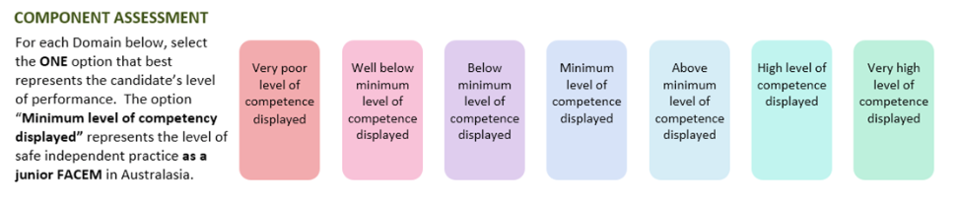

Medical Expertise

Communication

Prioritisation/Decision Making

DETAILED ASSESSMENT CRITERIA
Please use the following criteria to inform your ratings

Medical Expertise
- Explain that the injuries are inconsistent with the stated cause
- Explores whether someone else could have
- Explain the metaphyseal corner fracture will require immobilisation and pain relief
- Need for CXR/skeletal survey/possibly brain CT for ?post rib fractures/ICH
- Need for analgesia
- Need for coordinated paediatric and orthopaedic management of known injuries
- Offers support with SW
Communication
- Introduces self
- Non-threatening stance
- Allows parent to speak and doesn’t interrupt
- Sits down to encourage the same
- Attempts to verbally deescalate
- Uses simple language and a quiet voice, doesn’t raise voice
- Sets limits on what is acceptable behaviour

Prioritisation and Decision Making
- Explains need for paeds/ortho admission
- Explains FACS – mandatory report
- Explains Police involvement – mandatory report
- Explains that zero tolerance of violence and that security will be called if further escalation of aggression
- Does not allow child to go home

