OSCE Name: Mooshed Foots

Domains Tested
- Medical Expertise (50%)
- Scholarship and Teaching (30%)
- Communication (20%)

Candidate Information
A heavily intoxicated 19 year old female was being chased by police when she jumped from a garage roof and injured bilateral feet. She did not have a headstrike and denies pain anywhere else. She has been examined from top to toe by a competent registrar and has no other injuries. The RMO has asked you to take her through the XRays and explain the assessment and management of this injury.

Tasks:
- Explain the important features of the XRays to the RMO
- Outline the important aspects of assessing a trauma patient, generally and with reference to this particular injury
- Outline the management of this case.

Role Player Information

You are a PGY 2 RMO and have just arrived on shift. You have been looking at the foot XRays of a trauma patient who has been worked up by a registrar in resus.

You don’t feel very confident about interpreting them and have asked the consultant to explain them to you

You also are keen to know how to assess a trauma patient like this, and what you should specifically examine when people have this injury

Ask the following questions if not covered:

- Are there any tips on looking at calcaneal XRays?
- Does she need any other imaging ?
- What is the management from here?
- Her alcohol level was 0.34, how does that change things?

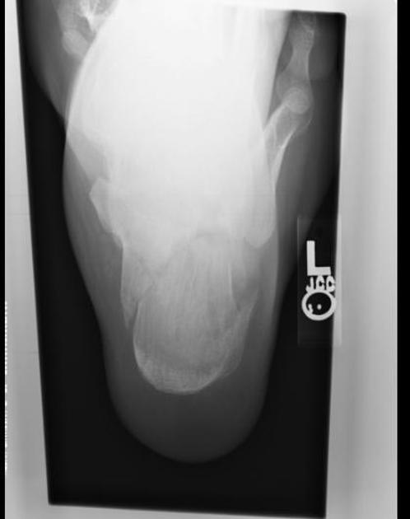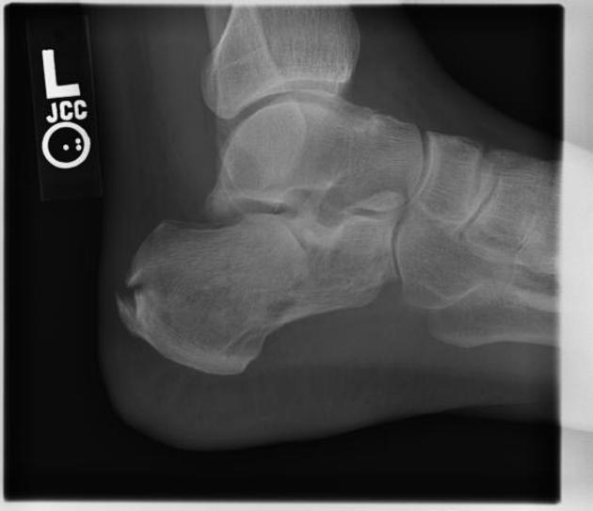
Marking Scheme

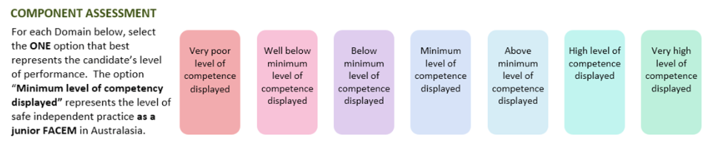

Medical Expertise

Communication

Scholarship/Teaching

DETAILED ASSESSMENT CRITERIA
Please use the following criteria to inform your ratings

Medical Expertise
- Explains view of calcaneal fracture and describes fracture appropriately
- Bohlers Angle, intraarticular vs extraarticular
- Assessment – primary/secondary survery in ED, assess back for risk of compression fracture, consideration of intoxication and distracting injuries
- Need for CT
- Elevate, rest, analgesia, NWB, ortho consult
Communication
- Good pace, check understanding, allows questions
Scholarship and Teaching
- Checks level of trainee
- Checks pre-existing knowledge
- Clarity of explaination
- Checks understanding and retention
