OSCE: Let Me Go

Candidate Information

Domains Tested
- Communication
- Medical Expertise
- Professionalism

A 38F has taken an unknown quantity of panadol tablets 2 hrs ago whilst intoxicated. She had a fight with her boyfriend, drank half a bottle of vodka then took the tablets whilst locked in the bathroom. She cannot recall exactly what she took but there were blister packs found totalling 60x 500mg tablets. Her partner called the police who brought her here.
The Psychiatry registrar has been referred to for admission, but has not seen her and a FACEM colleague of yours has held her for assessment under a mental health section. He has now gone home and handed the patient to you to follow up

She has a normal VBG, ECG and her first panadol level is due in 2 hrs. There are no findings on examination to suggest a toxidrome. She has a BAL of 0.36

She wants to leave and you have been asked to come and assess her.

TASKS
- Explain the current situation and intended onward management to the patient
- Explain the medicolegal frameworks/principles under which you are operating
- Answer any questions that the patient may have

Role Player Information

38F, Jilly
Unemployed, no kids, no reg meds, ETOH excess in context of recent relationship issues, no drugs

You admit to still being drunk but now state that you took the tablets to get some attention from your boyfriend. You don’t know how many you took but you feel fine and want to go home to sleep it off. You hve been feeling quite sad lately and have been thinking about harming yourself a lot. You are only brave enough to do it when you are drunk

You don’t understand why you have to stay here and don’t think its legal to keep you here because you “aren’t crazy”

You cant however guarantee your own safety if asked

You state that you are going to “call the police”, “Sue the hospital” if they don’t let you go

You have a friend who is a lawyer and she is going to help you.

“What are you going to do if I leave anyway”
“What’s so bad about panadol anyway”
“I can just take some antidote at home”
“I wont do it again”

Examiner Information

Marking Scheme

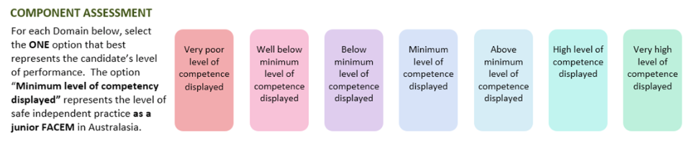

Medical Expertise

Communication

Professionalism

DETAILED ASSESSMENT CRITERIA
Please use the following criteria to inform your ratings

Medical Expertise
Explains need for 4 hr level +/- NAc with appropriate detail on timing/blood tests etc
Explains need for sobering up
Explains need for psych assessement
Explains disposition to SSU/med ward till medically cleared

Communication
Intros with name and level, rapport, active listening/establishes corncerns
Empathy
Non verbal comms
Verbal comms – rate/clarity/no jargon/open and focussed Qs
Emphasises legal aspects

Professionalism
Explains duty of care/mental health act principles
Explains override of autonomy in order to protect the patient
Least restrictive means

