OSCE: Ketamine Save

Candidate Information

Domains Tested
- Medical Expertise (40%)
- Prioritisation and Decision Making (30%)
- Teamwork and Collaboration (30%)

This station is a SIMulation based OSCE. You are expected to be the team leader in this scenario and will direct 1 doctor and 1 nurse to manage the patient.

You have been called into resus where a 5 year old boy has been having a ketamine sedation for exploration and suturing of a foot laceration – the registrar was sedating the patient and you were about to enter the room to fix the laceration. Everything was going well until the procedure started when the child developed inspiratory noisy breathing.

The registrar is managing the airway and is to remain at the head of the bed under your instruction. There is 1 nurse in the room also.

Tasks:
Direct the team to manage the patient from the head of the bed
Answer any questions that the team may have
Role Player Information

Doctor
You are a senior registrar who is delivering procedural sedation to a 5 year old boy for exploration and repair of a foot laceration. 30 mins prior to starting the procedure the patient was given a dose of cephazolin.

You think that the child has developed anaphylaxis secondary to the antibiotic. The child was known to have a penicillin allergy but has had cephalosporins without event previously on several occasions

When the doctor enters the room you should state
“I’ve given ketamine for the procedure, I’m worried he’s having anaphylaxis to the cephazolin he had 30 mins ago or the ketamine, can you help me. I’ve got the adrenaline and hydrocortisone coming”

Observations

P 130
BP 110/80
Sats 90% BVM 100% - no PEEP valve initially
RR 30
Temp 37.2

No rashes
No lip swelling/tongue swelling
Never hypotensive
No wheeze

Once the child is intubated you are to ask the following questions…

“How can you tell the difference between laryngospasm from ketamine and antibiotic induced anaphylaxis”

“What would we have done if we had gone IM instead of IV and couldn’t get a line in”

Nurse
You are an experienced ED nurse of 20yrs and can do all of the tasks that you are asked (if reasonably expected tasks for a senior nurse)

If the trainee gives you more than 2 tasks at a time – ask him which one you should do first

Examiner Information

A 4 year old child has had ketamine induced laryngospasm at the point of painful stimulus after being given 1mg/kg ketamine IV.

The registrar is convinced that it is anaphylaxis and wants to give adrenaline and hydrocortisone. The candidate should briefly check that there are no features of analphylaxis (BP/rash/swelling/temporal relationship etc)

He is bagging but the sats are dropping. The sats will continue to drop until the child is intubated after a full RSI dose of sedation and paralysis
Smaller doses of relaxant will be ineffective

Candidate should:
- Identify laryngospasm as the likely cause of the stridor
- Apply positive pressure with a PEEP valve to try and break the spasm
- Modified jaw thrust with Larsons Point pressure
- Deepen the sedation – ideally with a non ketamine alternative e,g, propofol 0.5mg/kg
- Draw up rocuronium 1.1mg/kg or sux 2mg/kg
- Prepare for intubation (ETT 5, bougie, curved 2 blade or VL etc)
- Administer paralysis and intubate
- Continue sedation with propofol, sedate with longer acting paralytic if used sux

Additionally should consider
- Parental explanation/open disclosure
- Documentation
- Risk Man
- Support of team/debrief

Marking Scheme

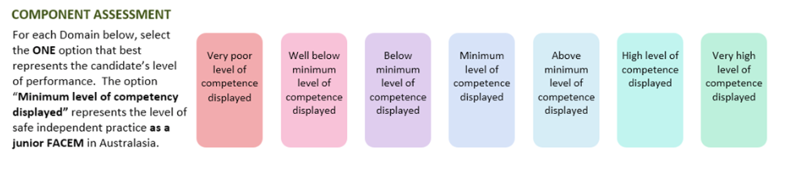

Medical Expertise

Prioritisation/Decision Making

Teamwork/Collaboration

DETAILED ASSESSMENT CRITERIA
Please use the following criteria to inform your ratings

Medical Expertise
Management
- Identify laryngospasm as the likely cause of the stridor
- Apply positive pressure with a PEEP valve to try and break the spasm
- Modified jaw thrust with Larsons Point pressure
- Utilises airway adjunts e.g. Guedel Airway
- Deepen the sedation – ideally with a non ketamine alternative e,g, propofol 0.5mg/kg
- Draw up rocuronium 1.1mg/kg or sux 2mg/kg
- Prepare for intubation (ETT 5, bougie, curved 2 blade or VL etc)
- Administer paralysis and intubate

Explains reasoning for laryngospasm vs anaphylaxis
- Time relationship to drugs
- No hypotension
- Tachycardia could be either
- No rashes
- No facial swelling
- No wheeze

Explains approach if had no IV in situ
- IO immediately
- IM sux (less appropriate as takes a long time but still possible)

Prioritisation and Decision Making
- Manages as for ketamine laryngospasm
- Rapidly moves through steps above when prior step is ineffective
- Consider discussion with parent

Teamwork and Collaboration
- Receives handover without interruption
- Clear instructions to team/airway doctor
- Doesn’t appear flustered
- Answers questions fully
- Considers the effect on the team – suggests debrief after the event is man

