OSCE: EOL Discussions

Candidate Information

Domains Tested
- Communication (50%)
- Prioritisation and Decision Making (30%)
- Health Advocacy (20%)

A 23 year old male, Brad, has been in your care for 30 mins after a self inflicted gun shot wound to the head. His CT is shown in the slide and you are sure that he has an unsurviveable head injury. He was initially intubated and started on a noradrenaline infusion. The neurosurgeon has been contacted and feels that the patient is not a surgical candidate due to futility. As a team you have decided that resuscitation would be futile and anticipate death within a matter of hours.

His wife, who has a 3 month old child, has just arrived at your ED and is unaware of what has happened.
She has been told by a police officer that he is in a critical condition and is waiting to speak to you.

The patient is in the care of another FACEM while you speak to the wife

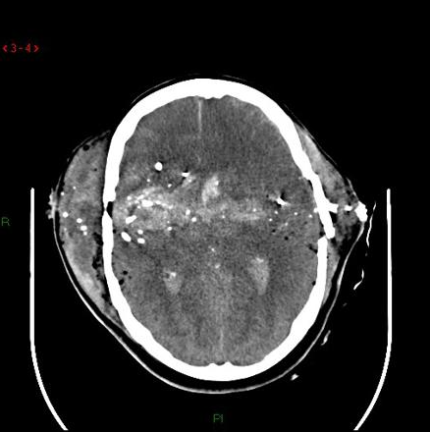
Tasks:
- Explain to the patient’s wife the current situation and the next steps in her husband’s management
- Answer any questions that she may have

Role Player Information

Jenny 23 F, Married to Brad, works in a pharmacy
1 Child 3 mths old, currently with your mother

Had a fight last night and went to your mothers house
Brad had a long Hx of depression and was physically abusive towards you for years
He had recently started an antidepressant and started to see a counsellor

You were called by the police today to say he had been involved in an “incident” and was critically unwell
You have no idea what has happened

You can’t believe he would do this and had been hopeful that he was recovering
You initially refuse to accept that he is going to die and want everything to be done for him – surely surgery and intensive care can fix it

You get angry if the doctor tells you that it is futile

You have your mum and dad nearby and they are supportive.
You don’t want to talk to the social worker

You ask “so what happens now, do we just let him die here?”, “Is he in pain?”, “do you think he will be able to hear/see me and our baby”, “how long do you think he will last?”, “Is there any chance he will survive?”

If not raised by the doctor you bring up that Brad’s sister received a kidney transplant and Brad and his family all feel very strongly in favour or organ donation.

Marking Scheme

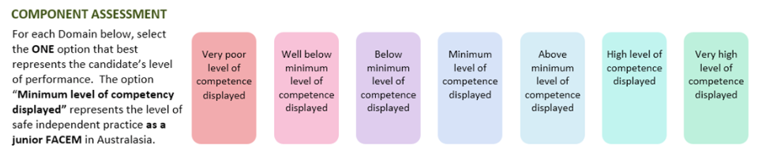

Communication

Prioritisation/Decision Making

Health Advocacy

DETAILED ASSESSMENT CRITERIA
Please use the following criteria to inform your ratings

Communication
Introduces self
Identifies the relative
Establishes current level of understanding of events
Demonstrates empathy, is professional and respectful
Non verbal skills – body language/space/eye contact
Appropriate verbal skills – rate,repetition when required/no jargon
Active Listening, allows emotional response
Summarises,. Checks understanding
Allows questions

Prioritisation and Decision Making
Justifies decision making – scan/neurosurgeon/evidence/futility
When organ donation raised appropriately escalates to ICU
Gives disposition options – ward level care vs ICU

Health Advocacy
Explains futility – certain death and that not for resuscitation in the event of cardiac arrest
Provides support – offers SW, help with onward process
Explains comfort measures
Offers to speak to other relatives/call NOK for wife
Elicits wishes around organ donation
Explores religious/cultural aspects of dying

