OSCE: Title of OSCE
Time: Double Station – 3mins reading, up to 17mins station
Author: Becky Day
Medical Expertise
Communication
Prioritisation and Decision Making
Teamwork and Collaboration

Clinical Scenario Stem
56 Male presents with sudden onset pre-syncope, chest pain and nausea. He was brought in by his wife. He has a background of NSTEMI 12 months ago and more recently has had several episodes of dizziness. He is awaiting a cardiology follow up appointment and a holter monitor. He has chest pain and a BP of 60/40. He looks diaphoretic and pale. He is unable to answer any questions as he is confused.

Instructions

Candidate
It is 2am and you are the FACEM on-call and have been called in from home to manage this unwell man. You have just arrived in the resus bay. His ECG is shown.

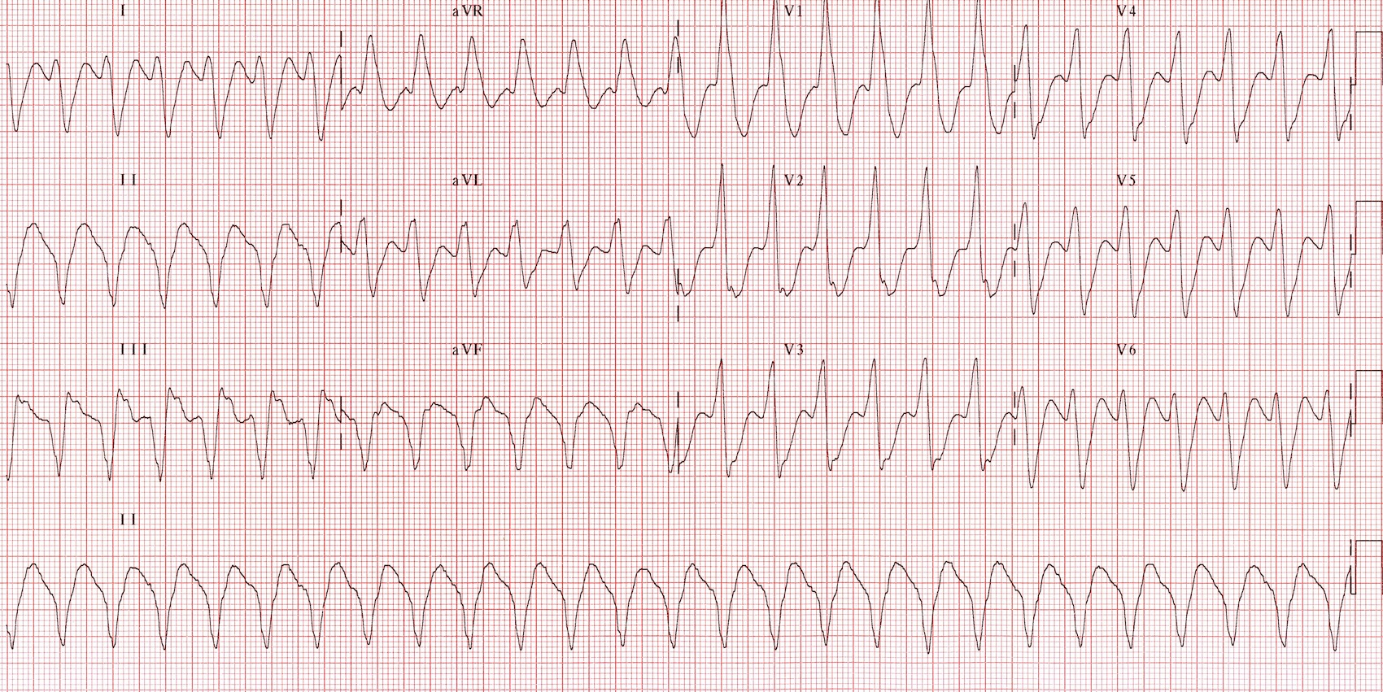

Your setting:
- Urban district hospital
- ED Staff: 1 junior registrar, 1 RMO and 2 resus competent nurses
- Retrieval response time 30mins
- Nearest Cath Lab,, CCU and HDU all 30mins drive by ambulance
- Onsite: ABG/Laboratory/Xray and CT
- No Onsite Cardiology Service
Your Tasks
- Lead the ongoing assessment and management of the patient clearly from the end of the bed
- Make any appropriate referrals and disposition decisions
- Deal with any questions that may arise from the team
The following domains will be assessed:
- Medical Expertise
- Communication
- Prioritisation and Decision Making
- Teamwork and Collaboration

Role Player Instructions
There is an expectation that the candidate will establish that the patient has haemodynamically unstable semi-conscious VT with evidence of cardiac ischaemia (Chest Pain) that requires urgent electrical cardioversion. They should ensure that the patient has preoxygenation, monitoring and appropriate analgesia and sedation. The first shock will be unsuccessful regardless of Joules. The second shock will be successful as long as it is a minimum of 100J. Shocks should be synchronised. The patients BP and pulse will improve after the 2nd shock. Disposition should be to HDU or CCU. He doesn’t require cath lab post procedure as there is no STE.

Registrar ACTOR
- Summarise the history thus far to the FACEM when they arrive
- 56M, BIB wife with nausea and dizziness
- Patient unable to give Hx as confused, hypotensive (60/40) and tachycardic (160bpm)
- Wife states that was fine one minute and unwell the next
- PMH. MI – stents 1 year ago. HTN
- Meds – Aspirin and Coversyl
- Wife is not present as has gone outside to talk to the rest of the family
- Not fasted
- So far had 2L IVF and some GTN for chest pain
- Summarise the exam findings, if asked to re-examine they do not change
- Exam findings – poorly perfused, CR 4s, Pulse 160 thready, chest scattered creps, abdo NAD, GCS 8, confused, PUPILS equal
- After the successful cardioversion you state that the patient is starting to wake up

- You were unsure about what to do and didn’t cardiovert the patient (if asked) because he wasn’t fasted and you haven’t done an anaesthetics term yet. You got confused about whether you could give amiodarone without a central line.

- When the candidate states electrical cardioversion is required, you suggest that maybe amiodarone might be better because the patient isn’t fasted

- You are capable of all core ED procedures except for independent intubation (line/defib/supervised intubation)

- Post cardioversion you ask “does the patient needs to go straight to the cath lab”
- Also ask “why does the defib have to be synced?”

RMO ACTOR
You need to directed to do most things but obey all instructions
You can put in IVs, BVM, use airway adjuncts and apply defib pads but anything more complex is beyond your skill level and you must voice this to the consultant
Inform the candidate that there has been a drop in the sats post cardioversion

Nurse ACTORS 1&2
You are resus competent and can put in IV’s, apply defib pads, work the defib (but need to be guided as to energy level as appropriate), draw up and give drugs. If an airway nurse is required you are also competent at this (shouldn’t be required in the perfect OSCE)
If the candidate opts to cardiovert you must NOT prompt for the energy level or sync the defib – if you are given no instructions use 200J and DON’T SYNC. If you are asked to apply pads to the chest – do so in a standard position unless specifically asked for AP pads.
You are not to prompt at any time, and can only obey the instructions given by the candidate – this will likely be to operate the defib or give drugs and fluids.

Patient
Mannequin. Patient has a GCS of 8 and is just mumbling. No history from patient and wife not present.

Examiner
You can provide the following:
- VBG- Metabolic acidosis and high lactate
- CXR – normal
- BSL – 7.1
If the candidate asks for an anaesthetist or cardiologist, they are currently with another very sick patient in ICU doing a pericardiocentesis – they will be available in 20mins

Scenario Set up
Mannequin
ISimulate
Defib (the nurse should know how to operate)
Drugs available – amiodarone, lignocaine, adenosine, opiates, midazolam, ketamine, sux, roc, atropine, sotolol (all drugs are just saline drawn up and labelled as the appropriate drug by one of the nurses)
IV lines and Fluids- NaCl
2x IVC in situ at scenario start
All airway equipment and checklist
O2, suction

Key Actions Expected from Candidate
On arrival to resus room
- Introduce self and learn the names of the resus team
- Take the handover from the registrar (who gives a clear and succinct account of the progress so far)
- Interpret the ECG as VT and that the patient is haemodynamically unstable with ischaemic pain
- State the problem and the necessary action – Electrical Cardioversion
Preparation for Cardioversion
- Monitoring
- O2 pre-ox via NRB with CO2 nasal prongs
- 2x IV lines checked
- Fluid bolus
- Push dose pressors e.g. metaraminol
- Airway assessment and kit set up for intubation (checklist available)
- Drugs drawn with appropriate doses – e.g. fentanyl and midazolam, avoid ketamine in active ischaemia, avoid propofol as hypotensive
- Pads on AP ideally
- Brief team about safe defib, energy levels (100J min, 200J max), syncing defib
- Not penalised for starting amiodarone concomitantly as long as doesn’t interfere with rapidity of defib
- Attempts to get consent from patient/wife – not possible as not present and patient incompetent
Cardioversion
- Demonstrate safe oversight of defibrillation
- O2 away
- All staff clear
- Ongoing monitoring and rhythm strip print
- Identify failed 1st attempt and successful 2nd
Post Cardioversion
- Identify sats drop post defib and need for airway manoeuvres/adjuncts and BVM ventilation – rapidly improves with appropriate Rx
- Identify need for sedation to wear off with close monitoring and then CCU/HDU disposition
- Checks rpt ECG – SR without evidence of STE
- Advises that cath lab NOT appropriate and explains clearly why the defib has to be synced when the registrar asks

Assessment Criteria

DOMAIN | Performs poorly, nowhere near the level of a new FACEM | Performs  significantly below the level of a new FACEM | Performs below the level of a new FACEM | Borderline at the level of a new FACEM | Performs at the level of  a new FACEM | Performs very well, above the level expected of a new FACEM | Performs exceptionally and far exceeds the level of a new FACEM
Communication

Medical Expertise

Professionalism

Prioritisation

Detailed Assessment Criteria

Communication
- Introduces self to the team and clarifies team members names and roles
- Closed loop communication
- Clarifies the current situation and management thus far
- Uses clear language that is appropriate
- Answers the questions of the team

Medical Expertise
- As per Key Actions

Prioritisation and Decision Making
- Identifies that medical therapy inappropriate and electrical cardioversion necessary
- If uses amiodarone does so as an adjunct
- Identifies need for ongoing CCU/HDU level of care

Teamwork and Collaboration
- Is inclusive and allocates roles appropriately
- Invites input from team members and checks that they are happy with the planned approach
- Does not criticise the management thus far by the team.
- Once patient is cardioverted spends time explaining

