OSCE: The Complainer

Candidate Information

Domains Tested
- Communication (50%)
- Leadership and Management (30%)
-Professionalism (20%)

A 32F was seen in your Emergency Department 8 days ago with a cut to his wrist. She feels that he didn’t receive good treatment and contacted the patient advocate. You have agreed to meet with the patient to discuss the issues.

The patient feels that the issues are as follows:
- he waited for too long to be seen in ED
- the nurse didn’t provide adequate pain relief
- nobody seemed to care that
- nobody told him that he had nerve and tendon damage or that he needed an operation

You have reviewed the case notes and found the following information

She cut the medial volar surface of his wrist on a sheet of metal whilst at work.
Presented at 2pm – CAT4 at triage
Given panadol by a nurse at 2.15pm
Seen by an RMO at 3.30pm

RMO notes at 4pm state “deep laceration to volar surface of wrist, tip of thumb numb and likely flexor pollicis longis damage, needs exploration in theatre”

Nursing notes at 4.05pm state “patient became agitated and TOL. States he has waited too long and needs to go and pick up her daughter from school. Refused to stay and states will go to her GP for some proper care. Patient left before I was able to get the RMO to review”

The next day the patient was referred to the local tertiary centre and underwent an exploration and repair of a nerve and tendon.

You have not yet been able to speak to the doctors and nurses involved in the care

Tasks
- Respond appropriately to the complaint in person

Role Player Information

Jenny 32F, Works as a packer in a warehouse
Cut wrist on sheet metal.
Came to ED and waited for “ages” to be seen
Noone looked at the wound, cleaned it or offered anything more than panadol
Was sent for an XRay and was left around in XRay for 1hour with everyone ignoring you

When you got back to ED the dressing was soaked in blood but no one cared
The junior doctor came and looked at it but didn’t do anything and didn’t even mention nerve damage or tendon damage or the need for surgery. She just said she needed to get the senior doctor

Got sick of waiting after being in ED for 3 hrs, needed to pick up daughter so left
The nurse had an attitude problem and just shrugged when you said you were going to the GP’s instead
Could see all of the doctors and nurses just chatting in the distance – was very frustrating

Needed to pick up your daughter so couldn’t actually wait anymore anyway

Has no sick leave and now work so have no money
Don’t want this to happen to anyone else – just needed to know what was going on
You felt ignored and unimportant, and were in pain.

If the plan and follow up isn’t outlined, you state “so what are you going to do next, these doctors need disciplining”

Examiner Information

Marking Scheme

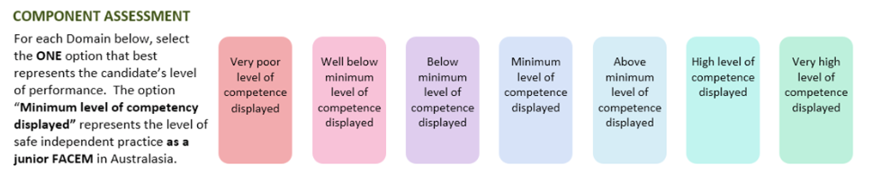

Communication

Professionalism

Leadership/Management

DETAILED ASSESSMENT CRITERIA
Please use the following criteria to inform your ratings

Leadership and Management
Outlines complaints procedure
Thanks the patient for highlighting an issue that needs investigation
Apologises that the patient had what they perceived as an unsatisfactory encounter in the ED
Outlines investigative process- notes/doctors and nurses/process/
Pledges to respond in a time frame

Communication
Introductions
Rapport
Verbal and non verbal communication
Allows the patient to speak, actively listens, non judgemental

Professionalism
Maintains a non judgemental and open minded approach
Ensures that does not judge the behaviour of either patient or staff until all information is collated (natural justice and procedural fairness)
When patient becomes accusatory doesn’t react

