OSCE No.

Candidate Information
Domains Tested
Medical Expertise
Communication

Clinical Stem
You are about to see a 56 year old patient in the minors area of your emergency department.
The triage information says “Intermittent pain in hand for 3 weeks, no trauma, tried panadol without resolution, feels lethargic and cold”
Obs: P50, Sats 98%, RR 16, BP 160/100

Tasks
- Take a focussed history and examine the patient
- Explain the likely diagnosis
- Explain the investigations, treatment and follow up

Role Player Information

You are a 65 year old retired man who lives with his wife. You are right handed
Over the last few months you have developed some pain in your right hand, a friend told you to come to the hospital in case you are having mini-strokes
It seems to be worse at night and wakes you up from sleep
The pain seems to be in the whole hand, and is hard to localise
It comes and goes, and sometimes happens in the daytime as well

Only if specifically asked:
Precipitants - occurs more when you are riding your bicycle/at night
Weakness – none
Sensory change – tingling in thumb and first 2 fingers
No trauma or injuries
Had weight gain, been feeling really cold and tired
No pain anywhere else
All other systems normal – no CP, SOB, infective sx, urinary or bowel sx, no headaches, no speech/vision issues etc
Noticed a bit of fullness in neck
No past medical history, medications, allergies
It isn’t really limiting what you do, but is an annoyance and is getting worse

At the 10minute mark, if not already asked, you must state “its really odd actually, I’ve gained about a 6 kilos and I’ve been really tired lately”

When examined
Sensation feels tingly in the thumb, first and second fingers
Normal power in hand and arm
Normal pulses
Normal colour
Normal skin
No tenderness anywhere in neck/limbs

Tinels test – if the doctors taps on your wrist the tingling and pain get worse
Phalens test – if the doctors asks you flex your wrists the tingling and pain get worse

Examiner information

The candidate has been asked to take a focussed history and examine a 65 year old man with pain in his right hand.

His clinical presentation is in keeping with carpal tunnel due to new undiagnosed hypothyroidism. Better candidates will not only identify the cause of the pain but also the underlying reason (thyroid disease)

Marking Sheet

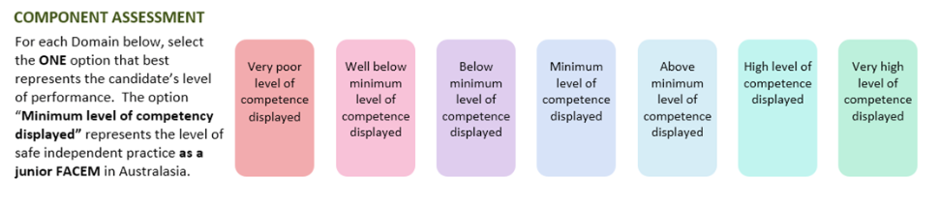

Medical Expertise

Communication

DETAILED ASSESSMENT CRITERIA
Please use the following criteria to inform your ratings

Medical Expertise - History
- Focussed history to establish
- Pattern of symptoms – intermittent, progressive, nocturnal especially
- Precipitants – riding bike
- Sensory change in median nerve distribution
- Lack of suggestion of spinal cause – no neck pain, no weakness, isolated to hand
- Hypothyroid symptoms
- PMH/Meds/Allergies
- Explores functional limitation
Medical Expertise – Examination
- Systematic examination including inspection, palpation, UL power (including median, radial, ulnar)
- Sensory exam identifies median distribution sensory change
- Tinel’s
- Phalen’s
- Thyroid Exam
  - Goitre
  - Skin and hair
  - Reflexes – slow relaxing

Communication
- Introduces self
- Establishes rapport

