OSCE: My back hurts
Time: Single Station – 4m reading, 7m station
Author: Rebecca Day
Medical Expertise
Communication

Clinical Scenario Stem
A 45 year old man presents to the fast track area of the ED with first episode of acute onset of lower back pain today. He has had difficulty walking. It occurred on getting out of bed this morning. His left leg feels “funny”. He has no other symptoms in any system. No trauma. No fevers. Bowels and urination are normal. No weight loss. He has a PMH of HTN only. No medications and is allergic only to Elastoplast. He is unemployed, he denies etoh/tobacco use and lives alone in a suburban unit.

Instructions

Candidate
Please perform a focussed examination of this patient given the above history. You must explain possible diagnoses and investigations to the patient. You will be warned at 5 minutes into the station to start explaining to the patient what the diagnosis is. Assume the PR and perineal sensation are normal.

YOU MUST NOT TAKE ANY FURTHER HISTORY FROM THE PATIENT – THIS IS AN EXAMINATION AND EXPLANATION STATION

Patient - actor
You are a 45 year old patient with back pain. You are not to give the patient any further Hx – this is NOT a history taking station. You have the following signs:

Steppage gate/foot drop (see https://www.youtube.com/watch?v=SWvEU8FYMFc)
Left sided foot drop/weak dorsi flexion.
Weak knee flexion
Weak foot eversion AND inversion
Weak hip internal rotation
Normal reflexes
Sensory Loss L5 (See below)
Tender lower lumbar area
NO tenderness over the fibular head

Ask the following during the explanation
- Is it cancer? My dad had cancer
- Do I need an operation
- Will it get better
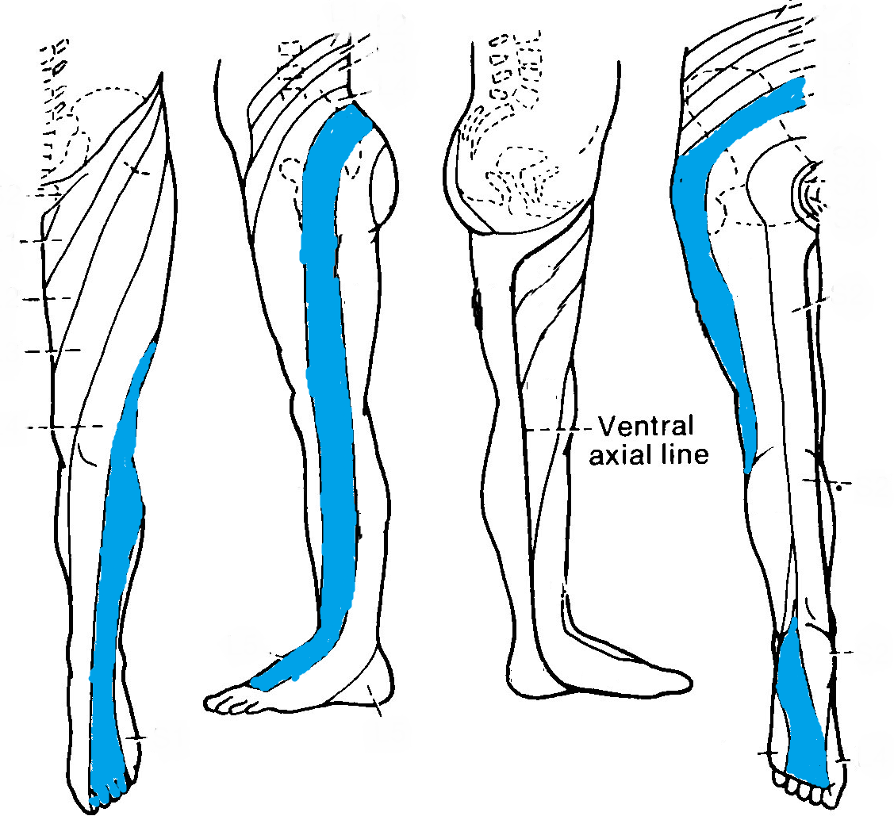

Examiner
If the candidate has not started to explain the findings and ongoing investigations to the patient at 5 mins they must be prompted to do so. 30 seconds from the end you should ask the patient to explain how they can differentiate between a common peroneal nerve injury and an L5 root problem.

Assessment Criteria

DOMAIN | Performs poorly, nowhere near the level of a new FACEM | Performs  significantly below the level of a new FACEM | Performs below the level of a new FACEM | Borderline at the level of a new FACEM | Performs at the level of  a new FACEM | Performs very well, above the level expected of a new FACEM | Performs exceptionally and far exceeds the level of a new FACEM
Communication

Medical Expertise

Professionalism

Prioritisation

Detailed Assessment Criteria

Communication
- Introduces self – name and grade
- Builds rapport
- Gives clear/unambiguous instructions during examination
- Explains plan succinctly and answers all questions unambiguously

Medical Expertise
- Appropriate Exam Technique
  - Inspects – trophic changes/scars/swelling/redness/back etc
  - Palpation of back for midline tenderness
  - Movement of back in all directions
  - Gait, heel and toe walking – cant heel walk on left
  - Legs - Passive movements/Active Movements/Tone/Power – all groups/Reflexes Sensation
  - Checks for pain over fibular head
- Gentle technique
- Identifies that likely L5 root lesion due to reduced power in dorsiflexion/knee flexion and foot eversion and inversion
- Identifies that L5 reduced sensation
- Explains to patient that needs further imaging – MRI best
- Explains need for orthopaedic consult
- Explains analgesia
- Good candidates will know that loss of inversion/weak hip int rotation signifies L5 root involvement (vs CPN injury)

NOTES

L5 Root Lesion -
- Weak dorsiflexion/toe extension
- Weak eversion
- Weak inversion
- Weak Hip Int Rotn
- Strong plantarflexion
- Ankle jerk present

Common Peroneal Nerve Lesion –
- Weak dorsiflexion/toe extension
- Weak eversion
- Strong plantarflexion
- Strong inversion
- Ankle jerk present

Sciatic Nerve
- Weak plantar/dorsiflexion
- Weak Inversion and eversion
- Whole leg numb
- Ankle reflexes gone

Myotomes
Hip Flexion – L2 (femoral)
Hip Extension – L5 (inferior gluteal)
Knee Extension – L34 (femoral)
Knee Flexion – S1 (sciatic)
Ankle Dorsiflexion – L4 (deep peroneal)
Ankle Plantarflexion – S1 (tibial)
Great toe flexor – L5 (deep peroneal)

