OSCE 2B – Candidate Information

Theme: ECG Interpretation

Single Station_3 mins reading/7 minutes assessment

Domains Assessed:
Medical Expertise
Scholarship and Teaching

Clinical Stem
An RMO has approached you to discuss an ECG from a 76 year male patient who has presented with syncope. The patient is being safely managed by a senior registrar, and you do not need to participate in patient care.

Tasks
- Establish the important clinical information required to interpret the ECG
- Explain the ECG findings and their significance to the RMO
- Explain the necessary ED management necessary

OSCE 2A – Examiner Information

Candidate Receives the following information
Clinical Stem
An RMO has approached you to discuss an ECG from a 76 year male patient who has presented with syncope. The patient is being safely managed by a senior registrar, and you do not need to participate in patient care.

Tasks
- Establish the important clinical information required to interpret the ECG
- Explain the ECG findings and their significance to the RMO
- Explain the necessary ED management necessary

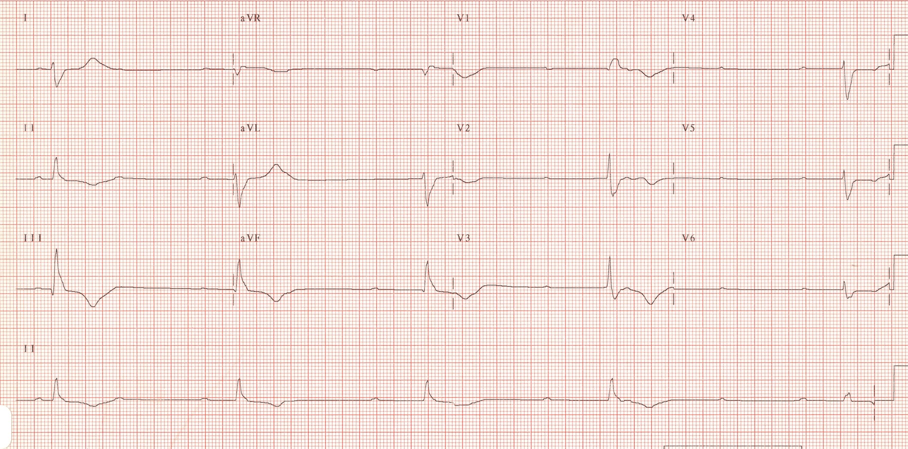

Marking Criteria

Medical Expertise
- Listens to the initial presentation and identifies appropriate historial features
- Stability – observations/end organ sx e.g. chest pain/confusion
- History of syncopal episode – timing, context, duration, nature etc
- Past history of cardiac disease/other comorbidities
- Meds – esp new meds
- No prior ECGs available to compare

- Examination findings/Results
- Normal obs except BP 140/90
- No localising findings
- No postural drop
- Normal bloods inc CMP/Trop/FBC/EUC/LFT
- Normal CXR except for large heart

- Explain ECG
- Complete Heart Block
- Atrial Rate 60
- Ventricular Rate 30
- AV dissociation

- Explains the necessary management
- Atropine 500-600mcg up to max 1.5mg – unlikely to work
- Fluids
- Adrenaline infusion or Isoprenaline infusion (doses not required)
- External pacing as last resort
- Sedation analgesia
- AP paddles
- Rate 60
- Increase Joules till electrical capture – 10-15 above
- Mechanical capture check – pulse

- Urgent cardiology input
- Keep Monitored – CCU
- Likely need a PPM

Scholarship and Teaching
- Establishes the RMOs level of knowledge
- Allows questions
- Checks understanding
- Communicates appropriately
OSCE 2A – Role Player Information (RMO)

Opening information:

Ive seen this 76M with the registrar – he is totally happy managing the patient in resus.

The patient is a previously well man who has had a syncope at home today. He was feeling fine beforehand and then it just suddenly happened. He isn’t feeling too well now. I was wondering if we can discuss the patient and his ECG. I can see it’s slow but I’m not good at ECGs.

If asked details about the patient you can answer Qs with the following information but must be asked specific questions to tease out the information

The event – Had been feeling dizzy for a few hours. Was standing up washing the dishes when suddenly became unsteady, nauseated and sweaty. Can’t recall what happened then but thinks he fell. Found by wife on the kitchen floor. No evidence of seizures/tongue biting/ head trauma/incontinence. Has a sore shoulder.
No recent intercurrent illnesses
No chest pain/confusion/neuro sx
No comorbidities – Known to have T2DM and HTN
Meds – Aspirin, Lipitor, Avapro, Metformin, Metoprolol
NKDA
No FH
Investigations all normal – FBC/EUC/LFT/CMP/TROP/CXR/BSL – 6.5
Examines normally except for bradycardia and cool peripheries
No postural drop

Must be asked specifically to disclose obs
P 30
BP 60/40
Sats 98% RA
RR 14

If asked about YOUR interpretation of the ECG
“It just looks a bit funny, I can see it’s slow. But I really can’t say much more – I’m pretty bad at ECGs”

You understand everything that is explained to you when the ECG is explained

If the candidate mentions the correct abnormalities but doesn’t state COMPLETE HEART BLOCK you should ask – “What does that combination of abnormalities all mean?

If the candidate doesn’t go on to explain what needs to be done by 5mins you should ask “So what needs to be done?”

The candidate doesn’t need to explain the entire process of external pacing/sedation etc. If they have completed all of the necessary other treatments you can allow them to do this to gain higher marks but if they have missed important other treatments you can guide them back by saying “is there anything other than pacing?”

