OSCE 2A – Candidate Information

Theme: ECG Interpretation

Single Station_3 mins reading/7 minutes assessment

Domains Assessed:
Medical Expertise
Scholarship and Teaching

Clinical Stem
An RMO has approached you to discuss an ECG from a 76 year male patient who has presented with syncope. The patient is being safely managed by a senior registrar, and you do not need to participate in patient care.

Tasks
- Establish the important clinical information required to interpret the ECG
- Explain the ECG findings and their significance to the RMO
- Explain the necessary ED management necessary

OSCE 2A – Examiner Information

Candidate Receives the following information
Clinical Stem
An RMO has approached you to discuss an ECG from a 76 year male patient who has presented with syncope. The patient is being safely managed by a senior registrar, and you do not need to participate in patient care.

Tasks
- Establish the important clinical information required to interpret the ECG
- Explain the ECG findings and their significance to the RMO
- Explain the necessary ED management necessary

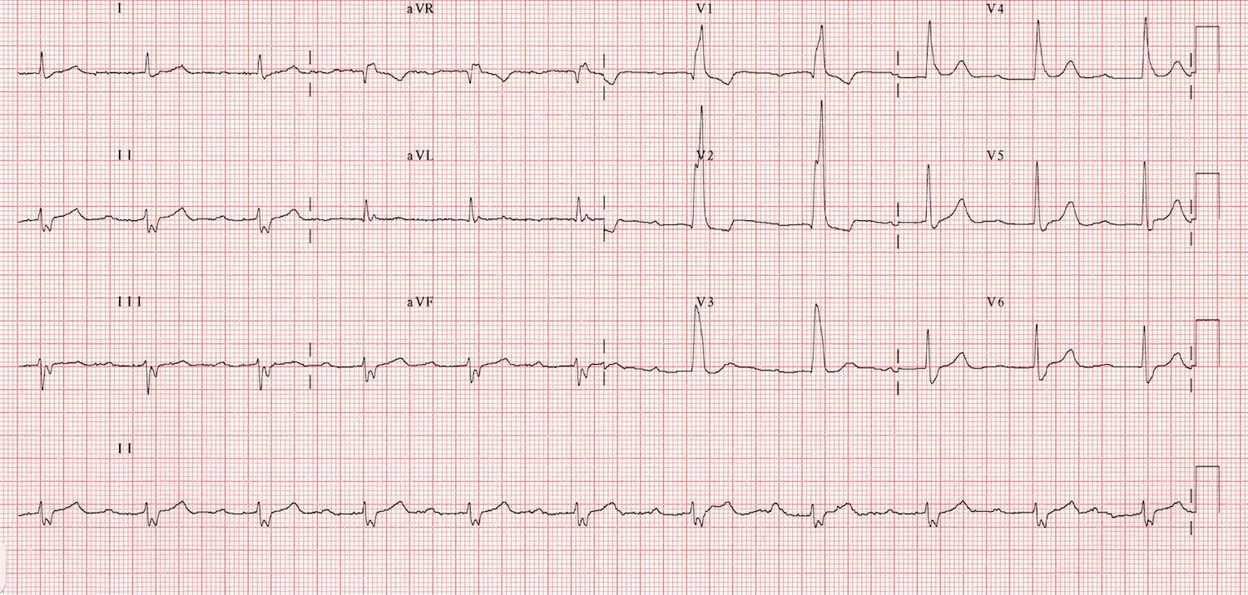

Marking Criteria

Medical Expertise
- Listens to the initial presentation and identifies appropriate historial features
- Stability – observations/end organ sx e.g. chest pain/confusion
- History of syncopal episode – timing, context, duration, nature etc
- Past history of cardiac disease/other comorbidities
- Meds – esp new meds
- No prior ECGs available to compare

- Examination findings/Results
- Normal obs except BP 140/90
- No localising findings
- No postural drop
- Normal bloods inc CMP/Trop/FBC/EUC/LFT
- Normal CXR except for large heart

- Explain ECG
- Trifasicular Block (incomplete)
- LAD
- RBBB
- First Degree HB
- High risk ECG – complete heart block potential

- Explains the necessary management
- Admit cardiology
- Keep Monitored – telemetry or CCU
- Likely need a PPM

Scholarship and Teaching
- Establishes the RMOs level of knowledge
- Allows questions
- Checks understanding
- Communicates appropriately
OSCE 2A – Role Player Information (RMO)

Opening information

Ive seen this 76M with the registrar – he is totally happy managing the patient.

The patient is a previously well man who has had a syncope at home today. He was feeling fine beforehand and then it just suddenly happened. He feels fine now and he really wants to go home. I was wondering if we can discuss the patient as his ECG. I can see it’s not normal but I’m not good at ECGs.

If asked details about the patient you can answer Qs with the following information but must be asked specific questions to tease out the information

The event – was walking out to collect the post when felt lightheaded and unwell. Nauseated so sat down on the grass and had a momentary LOC. Found by wife. No evidence of seizures/tongue biting/trauma/incontinence.
No prodrome/recent intercurrent illness
No chest pain/confusion/neuro sx
No comorbidities – specifically nothing cardiac, no prior ECGs at this hospital, no previous cardiac Ix
Meds – only a “preventative” aspirin
NKDA
No FH
Investigations all normal – FBC/EUC/LFT/CMP/TROP/CXR/BSL
Examines normally
No postural drop

Observations must be asked for specifically to be disclosed
P 66
BP 140/90
Sats 98% RA
RR 14
Afebrile 37.1

If asked about YOUR interpretation of the ECG
It just looks a bit funny
I can see its regular and not too slow or fast
But I really cant say much more – Im pretty bad at ECGs

You understand everything that is explained to you when the ECG is explained

If the candidate mentions the correct abnormalities but doesn’t state TRIFASICULAR BLOCK you should ask – “What does that combination of abnormalities all mean?

If the candidate doesn’t go on to explain the significance of the ECG prompt “so is this serious or can he just follow up outpatients”

