OCSE Marking Sheet
Local Anaesthetic Toxicity

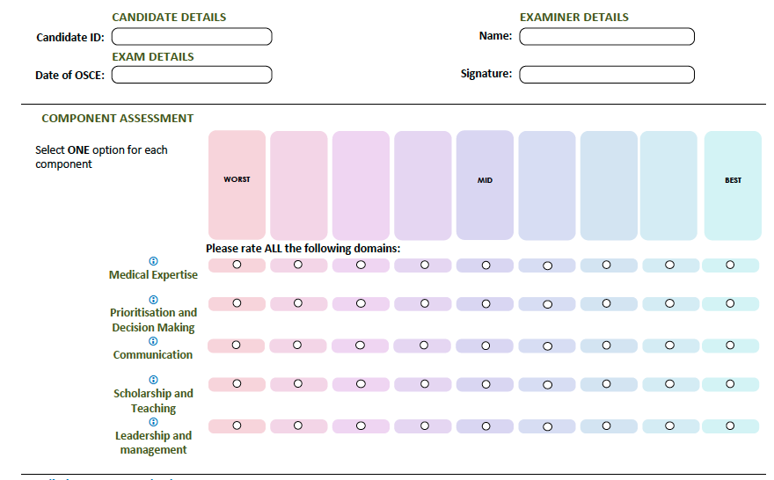

Detailed Assessment Criteria

Medical Expertise
- Focused clarification of history and examination
  - Identifies local anaesthetic toxicity as likely major issue with statement that 3mg/kg plain lignocaine exceeded or calculation based on patients weight performed
  - Identifies that RMO did not use aseptic technique/drapes/sterile gloves etc
  - Establish symptoms of local anaesthetic toxicity e.g dizziness/perioral tingling/tongue numbness/confusion/twitching
  - Voices concerns for likely severity/deterioration including
    - Seizures
    - Arrhythmias > cardiac arrest
    - Respiratory Depression
    - Haemodynamic instability
  - Requests appropriate monitoring and initial investigation/management
    - Move to resus
    - Obs now then continuous monitoring
    - ECG looking for prolonged cardiac intervals/arrhythmias
    - IV line
    - IV fluids for hypotension
    - Small boluses 1-5mg midazolam titrated for seizure prevention
  - Explains potential need for further management to RMO
    - Treatment of seizures with midazolam
    - Intubation using propofol or thiopentone
    - Hyperventilation
    - Inotropes for hypertension
    - Intralipid – dose not necessary as long as state as per protocol
      - 1mg/kg bolus repeated maximum of x3
      - Infusion of
    - Potential need
Prioritisation
- Disposition to ICU
Communication
- Calm, clear and appropriate content
- Does not criticise or berate RMO in front of patient
- Tailors communication to level of registrar
- Explains in lay-terms to the patient
Scholarship and Teaching
- Explains reasons for LA toxicity to the RMO clearly
Leadership and Management
- Deals appropriately with RMO debrief
  - Active listening, empathy, non judgemental
  - Explains that errors were made and remedial action is necessary
  - Recognises RMO distress and potential need to take time “off the floor”
  - Explains the system issues need to be addressed – level of supervision inadequate/lacking presence of senior doctor
  - States the need to address lacking supervision/system issues/potential bullying by nurses
  - Mention of open disclosure to patient – by consultant
  - Makes appropriate follow up meeting

Examiner Notes
- Candidate Performance Notes (Please provide candidate feedback including any areas of strength in their performance and suggestions for how they could improve.

- OSCE Incident Reporting Notes (Please provide details if an issue occurs which may influence this candidate’s exam outcome e.g. protocol breach, candidate illness etc.

